BIOGRAPHY: Julie Gable, CRM, CDIA, MIT, LIT

Julie Gable is the Principal of Gable Consulting, an independent firm that works with clients to bring business perspectives to information management issues. Ms. Gable has more than 25 years experience in the analysis, design and implementation of document-based information systems, specializing in document image processing, document management, and electronic records management. Clients include pharmaceutical companies, financial services firms, manufacturers, government and utilities. Gable Consulting is not affiliated with any vendor, sells neither hardware nor software, and does not accept fmders fees from any vendor.

Ms. Gable is the Associate Executive Editor of The Information Management Journal, a peer- reviewed professional journal published by the Association of Records Managers and Administrators (ARMA International). Ms. Gable was an Advisory Board member for Gartner Group’s Datapro Document Imaging Systems publication, and is a columnist ("At Your Service") for Imaging and Document Solutions Magazine. She is the author of "Writing the Functional and Technical Specifications" for International Data Corporation's Document Imaging series. Her articles have also appeared in Records Management Quarterly, The Records and Retrieval Report, and Imaging World. She regularly speaks on information management topics at national and international events.

Ms. Gable has served on the City of Philadelphia's Records Advisory Council and on the City First Imaging Committee. She holds a BS in Management from Drexel University and an MBA in Finance from St. Joseph's University, both in Philadelphia. She is an active member of both ARMA and the Association for Information and Image Management (AIIM). She has attained AIIM’s Laureate designation for achievement in Document Imaging and Document Management, and holds AIIM’s Master of Information Technology designation as well. Ms. Gable has earned the Computer Technology Industry Association's Certified Document Imaging Architect certification. She is also a Certified Records Manager (CRM).

BIOGRAPHY: J. Kenneth Blackwell

- 51st Secretary of State of Ohio
- Co-chairman, U.S. Census Monitoring Board
- Participant, National Summit on Retirement Income Savings
- Co-chairman of the Menu of Hope annual fundraiser for the Ohio Hunger Task Force
- Chairman of the Pension and Public Funds Committee, National Association of State Auditors, Comptrollers, and Treasurers (NASACT)
- Member, U.S. Department of Labor Advisory Council on Employee Welfare and Pension Benefit Plans
- Board of Directors, National Taxpayer's Union
- Co-Chairman, Memorial to Our Lost Children
Columbus Chapter of ARMA
C/o Rob McGlumphy
Vorys, Sater, Seymour & Pease LLP
52 East Gay St., P.O. Box 1008
Columbus, OH 43216-1008

Managing Electronic Records
1-Day Seminar

April 5, 2001

Seminar Leader
Julie Gable, Principal of Gable Consulting,
a nationally known expert on electronic records management

Keynote Address
J. Kenneth Blackwell
Ohio Secretary of State
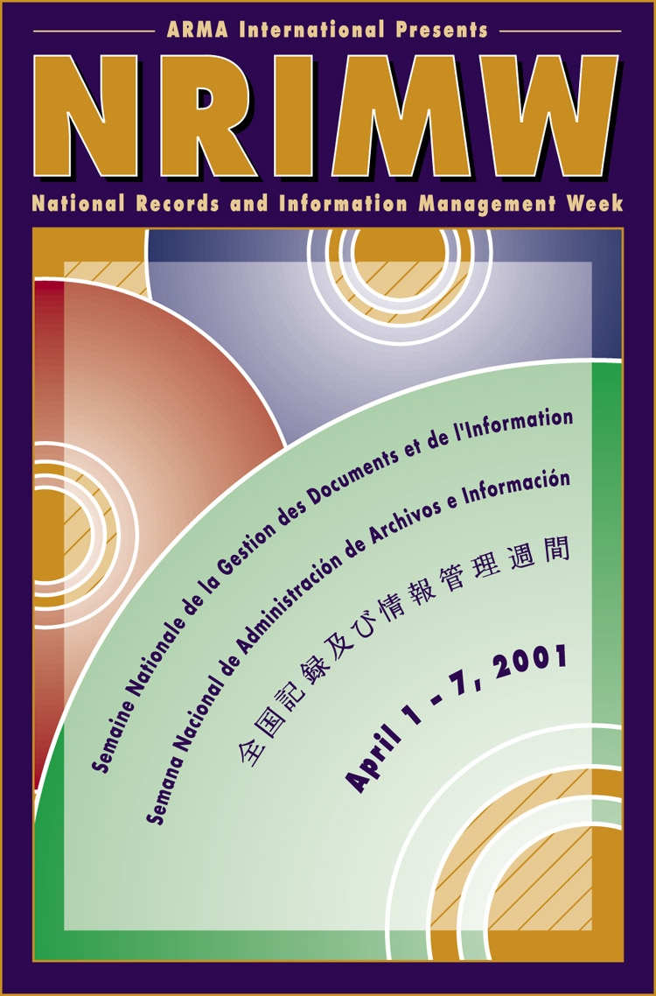

Concourse Hotel

4300 International Gateway

Columbus, OH 43219
At Port Columbus International Airport
8:30 AM – 4:30 PM

Hosted by The Greater Columbus Ohio Chapter - ARMA (Association of Records Managers and Administrators), to commemorate National Records and Information Management Week (NRIMW), April 1-7, 2001.

Managing Electronic Records
Seminar, April 5, 2001

The Greater Columbus Ohio Chapter - ARMA is hosting a full-day seminar April 5, 2001 on "Managing Electronic Records" to commemorate National Records and Information Management Week (NRIMW), April 1-7, 2001. The seminar leader is Julie Gable, Principal of Gable Consulting, Wyndmoor, Pennsylvania, who is a nationally known speaker on electronic records management. J. Kenneth Blackwell, Ohio Secretary of State, will deliver the keynote address.

Highlights of the Seminar
- An analysis of available software products to manage electronic records
- Insight on how records management software will operate in your real-world environment, including roles and responsibilities, work rules, and conversion strategies
- What to do before you buy ERM software, including realistic expectations for ERM integration with document management products, based on case studies
- Looks at emerging changes and future developments in software, including autoclassification, electronic signatures, and application service providers

Benefits of the Seminar
- Gain an understanding of special issues and problems associated with managing electronic records
- Learn how you can improve the management of electronic records as working information resources
- Discover differentiators in ERM (Electronic Records Management) software and set realistic expectations for its use
- Acquire thorough knowledge of current ERM software capabilities and future directions

Earlybird Payment Deadline: March 16

SEMINAR SCHEDULE

8:30 - 9:00 Registration and Continental Breakfast
9:00 - 9:10 Keynote Address: J. Kenneth Blackwell, Ohio Secretary of State
9:10 - 10:15 Importance of Managing Electronic Records
Major Issues in Electronic Records
Document Management vs. Records Management
10:15 - 10:30 Break
10:30 - 12:00 Electronic Records Management (ERM) Software Functionality
Product Approaches, Differentiators, Comparisons, Pricing
12:00 - 1:30 Lunch
1:30 - 3:00 Capsule Summary of Morning Session
How ERM Will Work: What You Need To Know In Advance
Case Studies of ERM Implementation
3:00 - 3:15 Break
3:I5- 4:30 Changes in ERM Software: Autoclassification, E-signatures
Future Directions: Toolkits, Engines, Application Service Providers

Location: Concourse Hotel
4300 International Gateway
Columbus, OH 43219
1-800-541-4574
Located on the grounds of Port Columbus International Airport

Registration Information and Payment Options

Earlybird Regular

Before March 16 After March 16
ARMA member* $99.00 $125.00
Non-ARMA member $125.00 $149.00
Full-time Student $75.00 $75.00

Note: Payment must be received at ARMA by March 16 for the Earlybird registration fee.

*ARMA member or guest from same firm.

SEMINAR REGISTRATION FORM

ARMA member or guest from same firm
Non-ARMA member

Full-time Student

Name

Address

City, ST, Zip

Method of Payment

Cash Check

Return Registration and Payment

Columbus ARMA c/o Rob McGlumphy
Vorys, Sater, Seymour & Pease LLP
52 E. Gay Street, P.O. Box 1008
Columbus, OH 43216-1008

About ARMA:

Founded in 1976, ARMA is an individual membership association for records, information and knowledge management professionals. ARMA's members total more than 10,000 professionals in the United States, Canada, and 30 other countries, and include records and information managers, MIS, ADP and operations professionals, imaging specialists, archivists, consultants, librarians and educators.

Whether you are new or a seasoned professional, to records, information and knowledge management (RIM), ARMA provides you with information access, expertise and professional development to help you and your organization utilize your information assets strategically, cost-effectively and efficiently. The mission of ARMA International is to provide education, research and networking opportunities to information professionals, to enable them to use their skills and experience to leverage the value of records, information and knowledge as corporate assets and contributors to organizational success.

Earlybird Payment Deadline: March 16

