Before this happens to You…
Prepare!
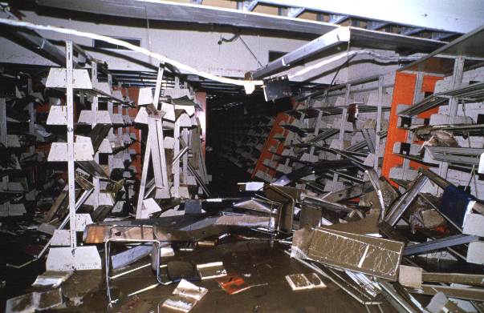
Attend!
The Emergency Disaster Plan Workshop
Sponsored by
LILRC Conservation/Preservation Committee
- Learn how to evaluate your library for potential hazards
- Learn how to write an Emergency Disaster Plan
- Learn how to deal with fire, flood, theft, and other threats
April 5th 2001 - Thursday (9:30am to 4pm)
May 24th 2001- Thursday (9:00am to noon - optional)
Dowling College Library, Oakdale, NY
Presenters: Sue Terry and David Jank
NO LUNCH PROVIDED(may use College cafeteria)
Committee will provide Continental Breakfast
Cut and send to: Virginia Antonucci, Regional Archivist-LILRC-Melville Library Building, Suite E5310 Stony Brook, New York 11794-3399

Name:__________________________________________ Tel. #_________________

Organization:______________________________________________

Please include check payable to LILRC for (Registration fee- $10) (CEUs of .5-fee $5)

