RECORDS & INFORMATION MANAGEMENT SPECIALIST

TEXTBOOK ORDER FORM

Spring 2000/2001

Textbooks may be purchased at the Chippewa Valley Technical College bookstore or mail payment in the enclosed envelope to:
Attention: Bookstore
Chippewa Valley Technical College
620 W Clairemont Ave
Eau Claire WI 54701

Name | Make Check Payable to Chippewa Valley Technical College  Credit Card Payments: _____MasterCard _____Visa  Credit Card # __________-__________-__________-__________  Expiration Date _________________
Address

City, State, Zip

Phone Number

To have the material mailed to you, fill in the book price in the "total amount" column. Please verify the course number to
ensure delivery of correct textbooks. Calculate shipping and enclose the correct amount with this order form.
NOTE: ALL PRICES ARE SUBJECT TO CHANGE

Price Total
Author Book Title Edition Publisher Each Amount

176-100 INTRO TO RECORDS & IMAGE MANAGEMENT (INTERNET)
NO TEXT REQUIRED

176-105 RECORDS & IMAGE MANAGEMENT (INTERNET & PRINT BASED)
176-116 RECORDS & IMAGING SYSTEMS (INTERNET & PRINT BASED)
Robek Information & Records Management 4th Glencoe 62.65 _____________

176-111 RECORDS CLASSIFICATION SYSTEMS (INTERNET & PRINT BASED)
176-121 RECORDS & IMAGING APPLICATIONS (INTERNET & PRINT BASED)
Smith Records Management 6th ITP 50.10 _____________
Smith Records Management Study Guide 6th ITP 19.45 _____________
Smith Records Management (Project) 6th ITP 38.25 _____________

176-140 RIM ADVANCED APPLICATIONS (INTERNET & PRINT BASED)
NO TEXT REQUIRED

BOOK TOTAL _____________

($4.00 for first item, .50 for each additional item) SHIPPING & HANDLING _____________

TOTAL ENCLOSED _____________



RECORDS AND INFORMATION MANAGEMENT

SPECIALIST CERTIFICATE

Chippewa Valley Technical College is excited to share information with you about a new, state-of-the-art Records and Information Management Specialist Certificate. The certificate is totally through Distance Learning for managers or non-managers at any level who are employed or seeking employment in an information-related position or job advancement.

Each course is 3 credits. You will receive a Records and Information Management Specialist Technical Certificate after completing 15 credits, or the five courses. Each course is sixteen weeks long. Enrollment periods are every eight weeks.

Fees for June 2000 to May 2001:
Course No. | Course Title | Credits | Total Cost
176-105 | Records and Image Management | 3 | $188.00
176-111 | Records Classification Systems | 3 | $193.50
176-116 | Records and Imaging Systems | 3 | $193.50
176-121 | Records and Imaging Applications | 3 | $193.50
176-140 | RIM Advanced Applications | 3 | $193.50

To Register: Call (715) 833-6487 with a credit card. Be sure to transfer to the bookstore then to order you text. To contact a counselor for more information, call CVTC at 1 (800) 547-2882 or (715) 833-6487, or call the instructor, Mary Welch, at (715) 833-6376. (E-mail: mwelch@chippewa.tec.wi.us)

Thank you for your interest in the Records and Information Management Specialist Certificate. We are excited about the opportunity to provide you with the state-of-the-art technology necessary to succeed in the field of Records and Information Management.


Sincerely,

Mary Welch
Instuctor

bm:MW13
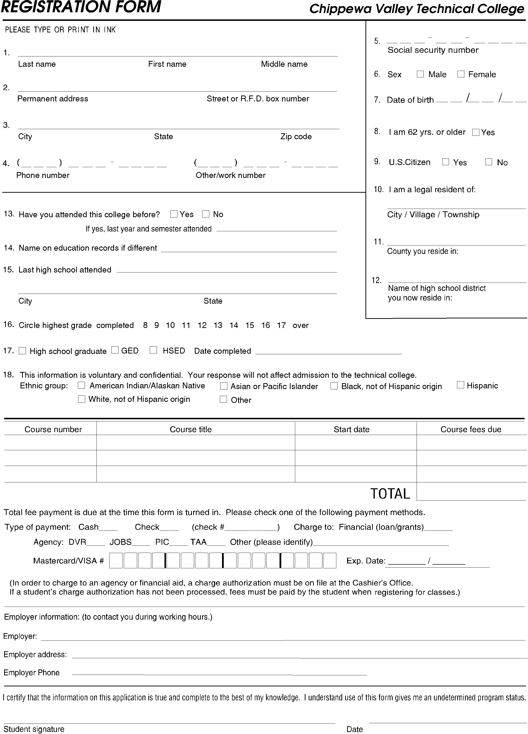
Registration and Payment Information

Chippewa Valley Technical College offers convenient ways to register. Payment is required at the time of registration.

1. Phone-In Registration
Credit Cared Payment Required (MasterCard, Visa, or Discover)
To register by phone, call (715) 833-6487 or 1 (800) 547-2882. Be prepared to give the information requested on the registration form included with this packet. Have your credit card number and expiration date ready to give to the operator. A schedule and receipt for payment will be mailed to you the following business day. Be sure to also order the textbook.
- Phone lines are open Monday through Thursday 7:30 a.m. through 6 p.m. and Friday 7:30 a.m. through 4:30 p.m.

2. Mail-In Registration
Check or Credit Card Payment (MasterCard, Visa, or Discover)
Complete and mail the registration form included with this packet along with your check to: Chippewa Valley Technical College, Information Service Center, 620 W. Clairemont Avenue, Eau Claire, Wisconsin 54701. If paying by credit card, complete the credit card section found on the registration form and mail to the address listed above. Be sure to also order the textbook. Upon receipt of registration and payment, a schedule and receipt for payment will be mailed to you the following business day.

