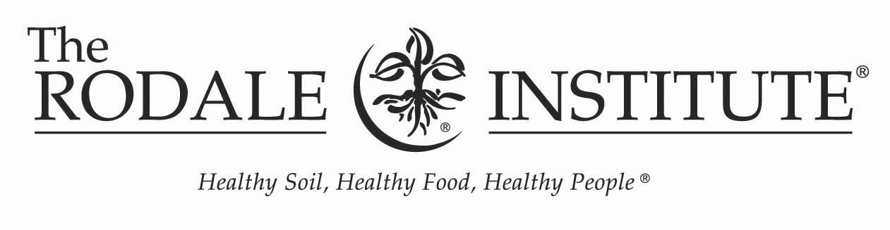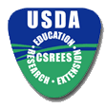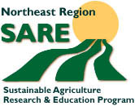

Building Healthy Soil – Building Healthy Farms
Field Day
Friday, July 16, 2004
The Rodale Institute®
611 Siegfriedale Road
Kutztown, PA 19530
Featured speakers and topics:
- Organic No Till – Jeff Moyer, Farm Manager, The Rodale Institute®
- Cover Cropping Strategies – Dr. Ray Weil, University of Maryland
- Increasing Crop Yields with Mycorrhizae – Dr. David Douds, Eastern Regional Research Center, USDA – ARS
- Benefits and Use of Compost Tea – Matthew Ryan and David Wilson, The Rodale Institute®
For more information and to register: fax, mail, email or call

The Rodale Institute®
Attn: Maria Pop, Training Coordinator
611 Siegfriedale Road
Kutztown, PA 19530
Phone: (610) 683- 1481
Fax: (610) 683- 8548
Email: maria.pop@rodaleinst.org

Name(s): ________________________________________________________________________________
Farm Name or Organization: ________________________________________________________________
Address: _________________________________________________________________________________
Phone: ________________________ Email: ____________________________________________________
Lunch choice: meat _________ vegetarian __________

