Julia Franco SLA Conference, June 2003

Editorial Library Training the Trainer

Los Angeles Times
julia.franco@latimes.com

Guideline for Training/ Instructional Handouts

Printing/ copying
Clean, clear handouts look professional, and are easier for users.

Don’t keep using an old master to make copies, and don’t copy from a copy.

Check the first copy before you make multiples to make sure that it’s printing straight, nothing is running off the page.

No text should be illegible. Adjust your copier settings if you have items on your page that are both very dark and very light.

Format
Try to have a consistent format, with an identifying logo or header, so it will be easy for users to recognize materials that come from the library.

Use the same font for all your handouts.

Try walking through the process yourself, using your handout. See if it’s easier to use if it’s only printed on one side of the paper. If you print on two sides to reduce paper, make sure your page breaks come in sensible places.

Content:
Never overestimate the level of knowledge, or expertise, or memory of your users.

Start with the basics –
how to get to the program or database (URL, or location of link or ‘button’) how to log on ( is a password needed, is it IP recognition?)
where to begin the search (where is the ‘search box,’ or is there another link on the intro page?)

“Borrow” from extant documentation.
Cut and paste from vendors Help / Users Guides
Find user guides and tips on the web
Newslib postings
(Do you need permission to reprint? Always give credit to your sources! )

Offer step-by-step directions and illustrate whenever possible.

Organization:
Keep at least one hardcopy of everything you produce. They are good reference when you’re creating new documents -- format, content, layout, terminology. (They are also a handy reminder at the end of the year of how much time you’ve spent!)

Name and date every revision. Use a small textbox at the end of each handout so that you can find the file easily when you need to print out a clean copy or revise the contents.

Keep discrete folders on your hard drive, named so that you can instantly identify the type of contents. Instead of one called “Instructional Materials,” name them specifically – Factiva handouts, L.A. Times online, Graphics databases, etc.

Keep a separate folder on your pc for often-used logos and images.

Follow up:
Always include the name and phone number of a person to contact for further help, including vendors’ customer service numbers.

If relevant, include e-mail addresses or websites for resources.

Technical tips for copying into a document you are creating
- If it’s text, highlight the portion you want to add to your document, then copy and paste into your document. Highlight by defining with your mouse, then either use Edit → Copy, or hold down the Control key and press C.
- Go back to your Word document, click where you want to put the copied text and either use Edit → Paste, or hold down the Control key and press V.
- The font may change when you paste it, or be different from the font you are using. To make it match use Edit → Select All to highlight the entire document, then select your font and size from the pulldowns on the toolbar. Don’t wait until you’ve finished creating your document to resize the font or your layout may be altered when you finally change it.

- If what you want is an image or table, use a screen ‘grab.’
- Move to the document you want to copy from and have what you want to use showing on your screen.
- Hold down the Alt key and press Print Screen. You won’t see any action.
- Move back to your Word document. Don’t paste directly into the document you are creating. Instead, open a new page by holding down the Control key and pressing N.
- Then paste your copied image onto the new sheet by using Edit → Paste, or holding down the Control key and pressing V.

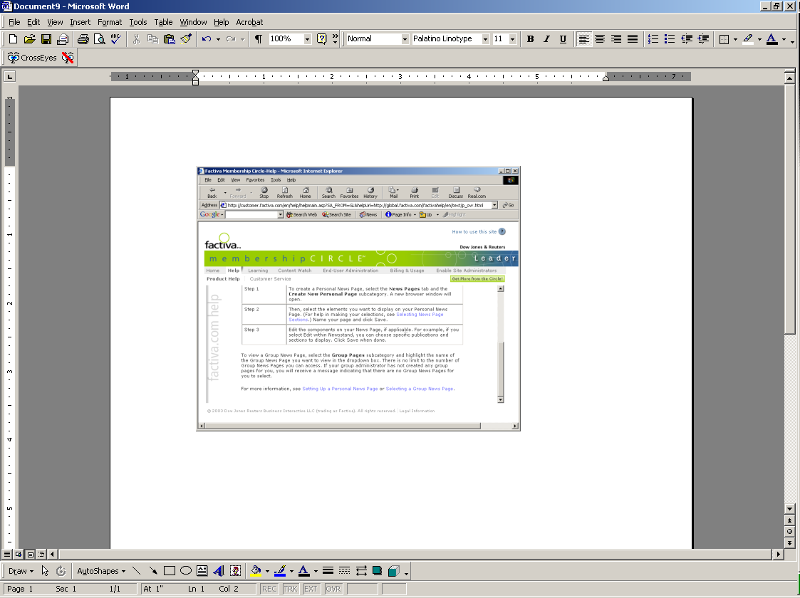
- You can now crop, resize, or cut and paste parts of this image, and then copy and paste your altered image into the document you are creating. This way you won’t have to keep re-formating the original document as you size your image.

- Clicking on the image will put an outline around it and bring up your Picture toolbar.

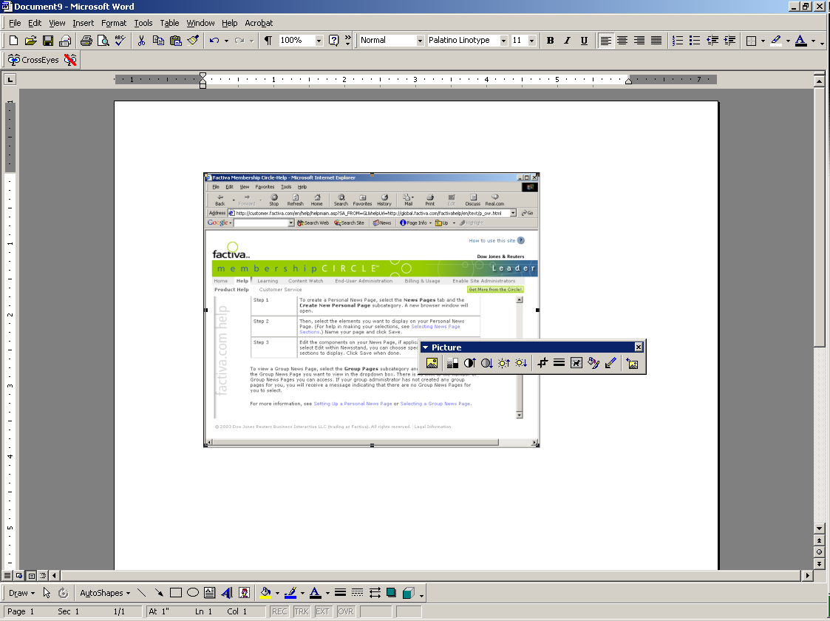
The outline produces the square dots called sizing handles at each corner and in the center of each line.
This is the Picture toolbar.
This is the cropping tool.

- To crop, click on the Cropping Tool. Move your cursor to one of the square dots, click, and drag the line.

- Once you have the image cropped, click once on it to define it. Then use Edit → Copy or Control, C.

- Move to the document you are creating. Click where you want to put the copied image, then either use Edit → Paste, or Control, V.
(Hint for making sure you can move this image around on the page if you need to –before you copy the image into your document create a text box to paste it into. This way you can move the box with the image inside. It is very hard to move the image on its own.)

Creating text boxes in your document
In Word, there is a toolbar at the bottom of the screen. The ‘text box’ tool looks like a lined sheet of paper with an ‘A’ in the upper-left hand corner.
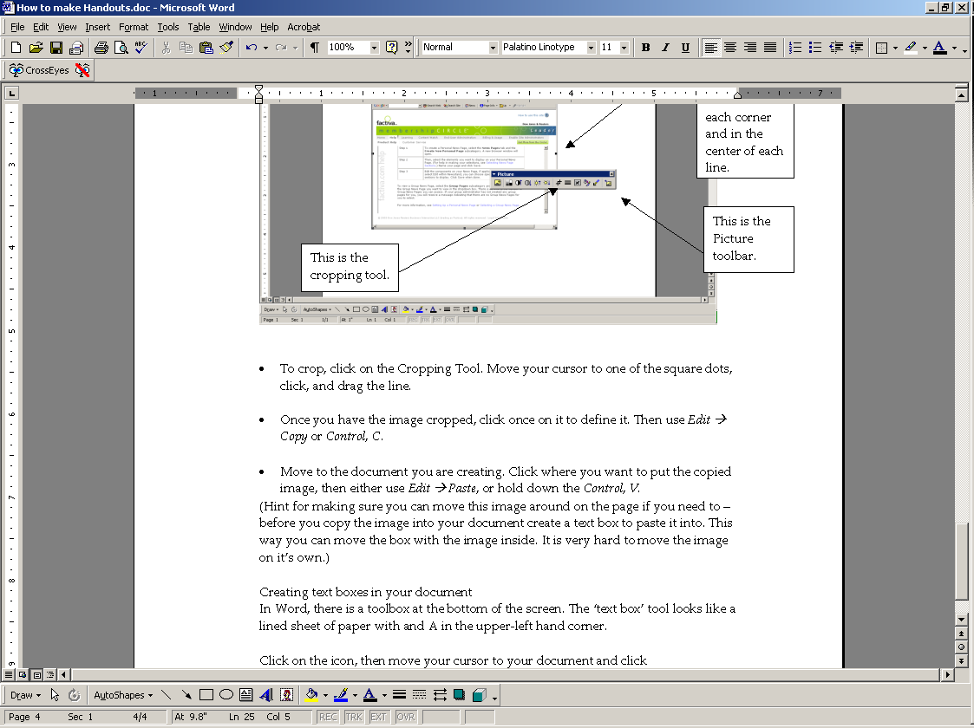

Click on the icon, then move your cursor to your document and click where you want the first corner of the box. Drag your cursor to size the box. the box will look like this
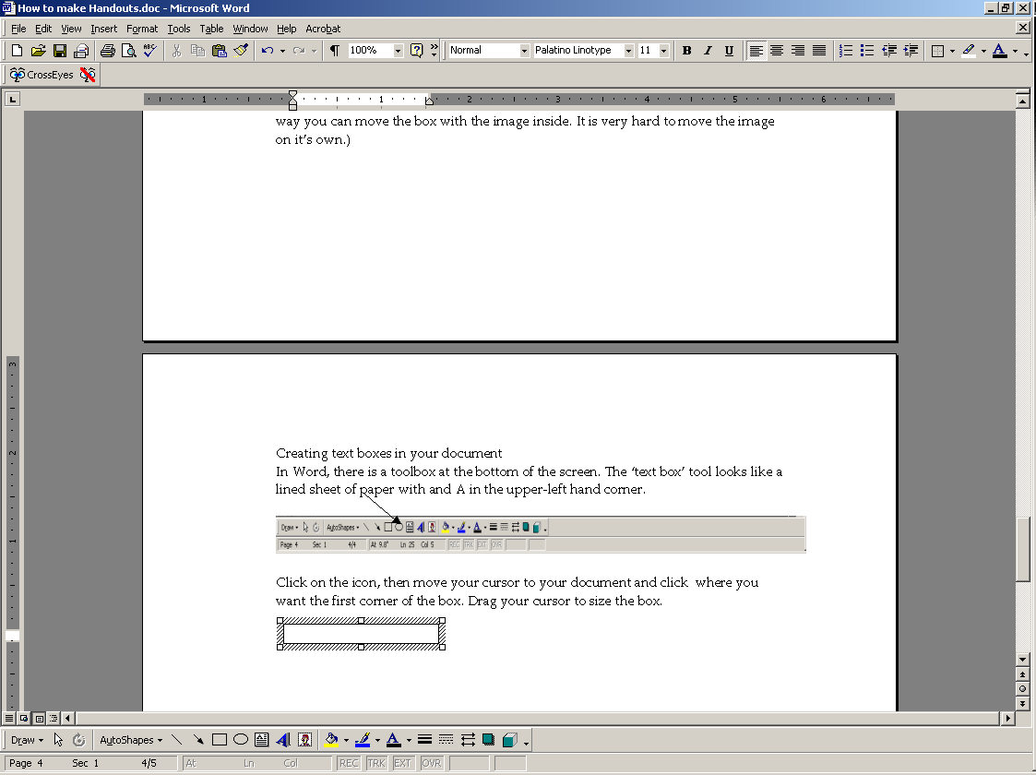
You can make it bigger or smaller by grabbing a corner, or you can make it taller or wider by grabbing a line.

To copy an image into the box, first copy the image from another worksheet or page, then return to your document and click inside the box. Then use Edit → Paste or Control V.

To make the outline of the outside box invisible, click on the box until the edge appears as either a stippled or hatched line. Go to the toolbar at the bottom of the page and click on the paintbrush icon. In the box that pops up click on “No Line.”
This will make the outline of the box invisible. You can make it reappear (so that you can grab it to move) by clicking in it anywhere.
Click here, then click on the Line Color tool (the paintbrush) and choose ‘No Line’
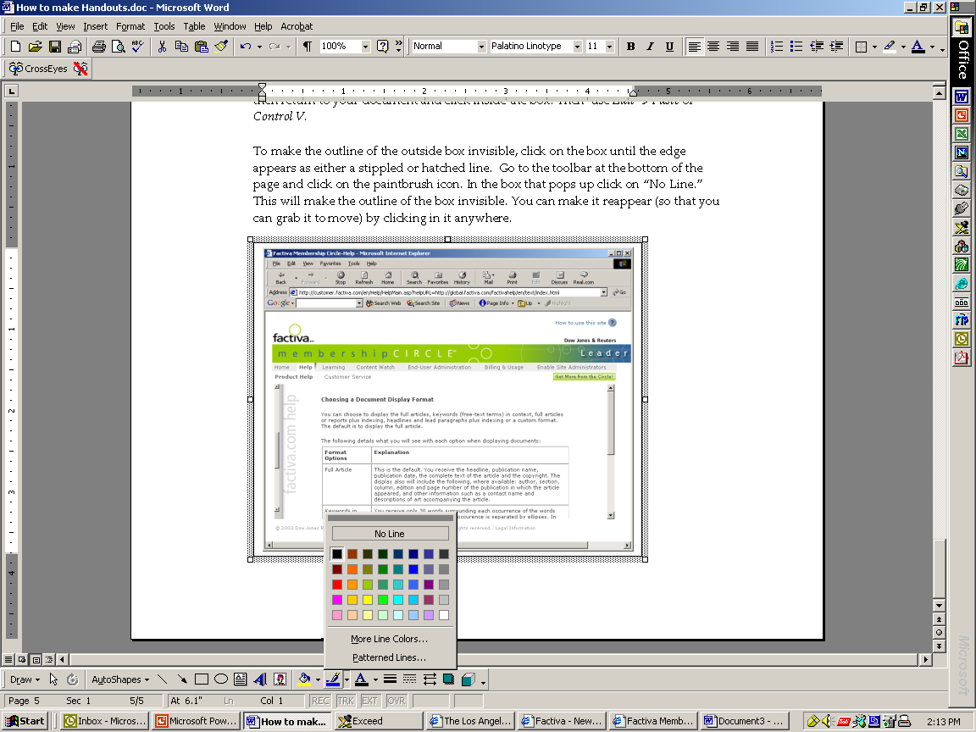
Line color tool

