Good Neighbor Initiative

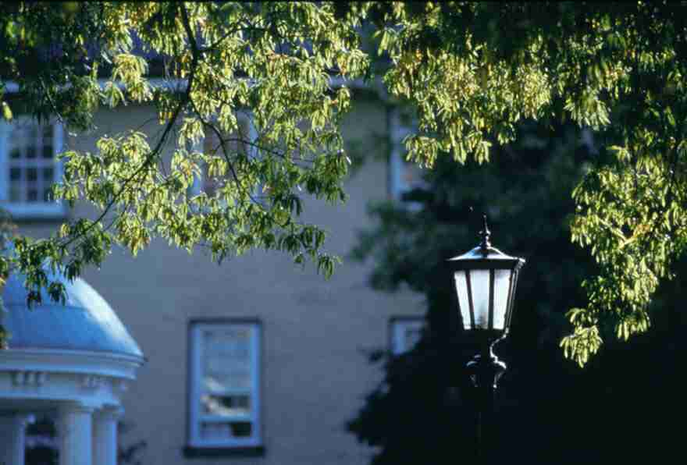
Photo by Will Owens (1999)

Written By Marc Nelson and Amon Anderson

With the support of:
UNC Chapel Hill Student Government
Chapel Hill Town Council
Division of Student Affairs


In January of 2003 the Chapel Hill Town Council passed the fifth draft of the Town’s Land Use Management Ordinance. This document covers a wide array of issues and concerns from environmental initiatives to off-campus student rental housing and is intended to work in conjunction with the Town’s Comprehensive Plan in shaping the future of the Town of Chapel Hill. Over the course of writing and editing the document, Town Council members and staff spent nearly two years meeting and listening to a diverse group of constituents, including students, faculty, and staff of UNC in an effort to ensure the viewpoints of all members of the community were considered. Some of the key points of the LUMO affect the student members of the University community and impart on them certain responsibilities in exchange for living in its neighborhoods.

The students of UNC-Chapel Hill are a vital and vibrant part of the Town’s past, present, and future. In addition to comprising a majority of the Town’s population and economic market, the undergraduate and graduate students of Carolina provide a sense of excitement, energy, and intellectual capacity that has made the Town of Chapel Hill a destination for people from around the state, nation, and the world. With this in mind, the leaders of student government in conjunction with the Office of Housing and Residential Education felt compelled to produce a document that will aid and inform students living off-campus of their most basic rights and responsibilities as members of the Chapel Hill community. In doing so, Student Body President Jen Daum and Graduate and Professional Student Federation President Branson Page commissioned undergraduate Amon Anderson and graduate student Marc Nelson to author the following document.

Please direct any questions or comments concerning the content of this document to the Office of Housing and Residential Education at (919) 966-4045.

Responsibilities of Rental Property Owners

- Make all repairs and do whatever is necessary to put and keep the premises in a fit and habitable condition
- Keep all common areas of the premises in safe condition
- Maintain in good and safe working order and promptly repair all electrical, plumbing, sanitary, heating, ventilating, air conditioning, and other facilities and appliances supplied or required to be supplied by the landlord if notified by writing in a timely manner by the tenant
- Provide operable smoke detectors
- Distribute material regarding “Rental Licensing Program” provided by the Town of Chapel Hill. This can be located at the Town of Chapel Hill’s website, http://townhall.townofchapelhill.org/inspections/rental_licensing.htm
- Provide written proof, including landlord signature, of dwelling inspection upon arrival of tenants
NOTE: Chapel Hill Housing Code is available at Town Hall, 306 N. Columbia St. or www.townofchapelhill.org. If renters are concerned with a landlord’s compliance with duties, please contact the Town of Chapel Hill Inspections Dept. at 919-968-2718.

Responsibilities of Tenants

- Keep the part of the premises that the tenant occupies and uses as clean and safe as conditions permit and cause no unsafe or unsanitary conditions in the common areas
- Dispose of all ashes, garbage, and other waste in a clean and safe manner
- Keep all plumbing fixtures in the dwelling unit clean
- Not deliberately or negligently destroy, deface, damage, or remove any part of the premises, nor render inoperable the smoke detector provided by the landlord
- Be responsible for all damage, defacement, or removal of any property inside a dwelling unit in the tenant’s control
- Notify the landlord, in writing, of the need for replacement or repairs to a smoke detector and any other repairs

Complaints

All citizens are encouraged to resolve concerns by first contacting their landlord or property manager but if this is not successful, we encourage tenants to contact
Dispute Settlement Center
302 W. Weaver St.
Carrboro, NC 27510
919-929-8800
www.disputesettlement.org
for communication and mediation between two parties for no cost.

NC Real Estate Commission also provides landlord tenant advice, as well as other resources and may be accessed by their website: www.ncrec.state.nc.us or by phone at (919) 875-3700.

Housing Discrimination

Orange Co. requires nondiscrimination in housing regarding race, religion, ethnic origin, nationality, affectional preference, gender, family status, and veteran status. If you feel you are discriminated against, contact Human Services Coordinator at 968-2760 or Orange Co. Office of Human Relations at 245-2250 in addition to UNC Student Legal Services at 962-1303

Occupancy Requirements

The current Town of Chapel Hill Development Ordinance restricts occupancy of Single-Family, Two-Family or Two-Family – Duplex dwelling units. No more than four (4) unrelated persons may occupy a single-family house. Also, each side of a duplex may not have more than four (4) unrelated persons. For more information, contact the Chapel Hill Planning Department, (919) 968-2728.

Garbage Disposal

Curbside service:

Town roll-carts are maintained by the once-weekly curbside service. Household refuse is collected once per week at the street. Residents are responsible for bringing containerized garbage to the street and returning the container to the side or back of house.

- Use cans 32 gallons or smaller or Town-provided 68-gallon roll-carts
- Make sure that cans other than those provided by the town weigh less than 60 lbs when full
- Use cans that have tight-fitting lids and that are watertight and fly-proof
- Put all garbage and household refuse in watertight bags secured at the top
- Put all garbage at the curb by 6 a.m. on the day of collection but no sooner than 4 p.m. the day before. All containers are to be removed from the street by 6:00 a.m. on the day following collection
- There is a $25 per day fine for leaving your roll cart or can at the curb after your collection day.

Leasing

A lease is a written contract between the owner of the property (landlord) and the person renting the property (tenant). The terms of a lease are usually fixed for a year, though some landlords offer 3, 6, or 9-month leases.

Make rental agreements in writing to avoid misunderstanding of terms and conditions. Most landlords will offer lease or rental forms and although verbal contracts are binding, written agreements are generally much safer. Make sure you understand every clause before you sign.

Contents of a lease:

Information contained in a lease is legally binding, so read over the terms carefully to ensure that your rights are protected. Identify the expectations of your landlord and make sure that your lease contains the following information:

- Names and addresses of landlord and tenant
- Description of property being rented
- Dates of rental
- Amount and due date of payment
- When rent can be increased
- Penalty of late payment of rent
- Deposit amount, what it covers, and terms for reimbursement
- When and how lease is renewed/ended
- Responsibilities for repairs, maintenance, and payment of utilities
- Tenant’s responsibilities
- Policy on subletting
- Policy on decorating/modifying home environment
- Landlord’s responsibilities
- Right’s of entry
- Liability for injury and theft
- Occupant capacity
- Fee for replacement keys
- Policies on pets and children

Common Sense Checklist:

- Make sure appliances are in good condition and complete. Look at refrigerator, freezer, pans, ice trays, stoves, etc.
- Check for adequate ventilation, lighting fixtures, smoke detectors, phone jacks—making sure all are sufficient and functional
- Plumbing and drainage mechanisms in bathroom and kitchen; i.e. water pressure, water bills, water fixtures
- Furniture—existence, quality, furnished or unfurnished
- Windows and doors—locks, screens, functioning, security
- Parking—ensure that there is ample space and ask about payment or permits needed
- Ask about liability for theft and fire, is there insurance?
- Storage space—are there facilities, is there access, closet space?
- What are the quiet hour stipulations?
- Check about access to laundry facilities

Roommates

Be sure to maintain an open dialogue with roommates at all times and make sure that size and location of accommodation, total and personal possible rent, and furnishings are discussed before signing a lease. Other issues of discussion

- Will food be purchased collectively or individually?
- Will meals be prepared collectively or individually?
- How will these responsibilities be assigned?
- How will general housekeeping responsibilities be shared and assigned?
- How will the home be furnished and how will future home purchases be shared and used?
- How will payments of utilities be divided? Who will be responsible for mailing in various payments?
- How will responsibility for property damage be shared?
- What are individual privacy needs and expectations?
- What are guest and entertaining policies?
- What are smoking or non-smoking arrangements?
- What are needs and demands for cleanliness?
- What are pet policies?

Student Legal Services

Student Legal Services provides sample leases, roommate services, and the resources of three attorneys to assist in housing related conflicts as well as other legal needs of both on and off campus students. 962-1303

Responsibilities

The UNC Code of Conduct applies to all students, on and off campus, and can be accessed at the UNC Office of the Dean of Students online at http://studentaffairs.unc.edu/who_we_are/dos/index.html

Noise Ordinances

Sound levels are determined by measuring the decibel level of the sound at the boundary line of the property at which the sound source is located. Maximum allowable sound levels are based on three factors:

- time of day,
- day of week,
- the primary use of the property from which the sound is coming.

For residential purposes, the maximum decibel levels allowed is:

- 50 during the daytime: the hours between 7:00am-11:00pm on Sunday-Thursday and 7:00am-Midnight on Friday and Saturday
- 45 during the nighttime: the hours between 11:00pm-7:00am on Sunday-Thursday and Midnight-7:00am on Friday and Saturday

Vehicle Sound Systems and Boom Boxes:
It is unlawful to operate in such a manner that the sound coming from the equipment is detectable from a distance of thirty (30) feet from the source:
- vehicle sound system on public or private property, or
- boom box on public property.

Permits to Exceed Sound Limits

Permits may be obtained by persons wishing to host a temporary event at which sound levels may exceed the maximum allowable limits. A permit allows sound levels to exceed the standard limit by ten decibels. Permits are issued at the Chapel Hill Police Department, 828 Airport Road, Monday through Friday, from 8:30 a.m. to 5:00 p.m. The cost of a permit is $50. Permits are issued only for events held during daytime hours on Fridays and Saturdays. Applications for permits must be made at least seven days prior to the event. For more information, please call the Police Department at 968-2760.

Parking Ordinances

Residential Parking:

There are many streets generally close to the UNC-CH campus where parking is prohibited during specified hours except by use of a residential parking permit. Residents of these particular streets may qualify for special parking permits if a residence does not have adequate space for off-street parking. For more information specifically regarding parking permits or tickets please call Parking Services at 932-2912.

If you live in one of these areas and need to obtain a parking permit, you must complete a Residential Parking Permit Application and provide the following:

1. Your motor vehicle registration card, and
2. A valid motor vehicle operator’s license for the applicant, and
3. A deed, or other legal document, proving ownership or a lease agreement of a property in the permit area. Sub-letters can provide a letter from the legal resident indicating this relationship. A lease agreement must indicate the time period for which the lease is valid.

Temporary parking may also be approved for special events such as weddings. These requests should be made one week in advance in writing to the Parking Services office in the James Wallace Parking Plaza, 150 East Rosemary Street, Chapel Hill, NC 27514.

Front-Yard Parking:

The Town limits front-yard parking to 40% of the front yards in specifically designated areas. For more information about this requirement, please contact the Chapel Hill Planning Department at (919) 968-2728.

Important Phone Numbers

Animal Control 967-7383
*Board of Elections 245-2350
*Clerk of Court 967-4523
*Council Meetings 968-2743
*Driver’s License 929-4161
*Duke Power Billing Information 1(800) 653-5353
*Duke Power Chapel Hill Customer Service 967-8231
Fire (Non-Emergency) 968-2781
*Health Department 968-2022
Housing 968-2850
Inspections 968-2718
*Landfill 968-2788
Library 968-2777
Parking Services 968-2758
Parking Tickets 968-2758
Parks & Recreation 968-2784
Planning 968-2728
Police (Non-Emergency) 968-2760
Public Arts 968-2888x277
Public Works (Trash Pick-Up, Recycling) 968-2796
*Recycling 968-2788
Rental Licensing 968-2718
Snow on Streets 968-2796
*Social Services 968-2000
Street Maintenance 968-2796
*UNC Student Government Office 962-5201
*Student Legal Services 962-1303
Swimming Pools 968-2784
Town Attorney 968-2746 Town Council 968-2743
*Traffic Court 245-2200
Town Manager 968-2743
Transportation 968-2755
Trash Collection 968-2796
*Vehicle Registration 929-0204
*Water & Sewer 968-4421
Yard Waste Collection 968-2796
Zoning Regulations 968-2728

* Non-Town Numbers. All others are Town of Chapel affiliated.

