Sri:
Srimate Sri Perundevi Nayika Sametha Sri Devadhiraja Parahbrahmane nama:
Srimate Ramanujaya nama: Srimate Sri Vedanta Desikaya nama:
Sri Vaikunta Ekadasi Garudotsava Patrika

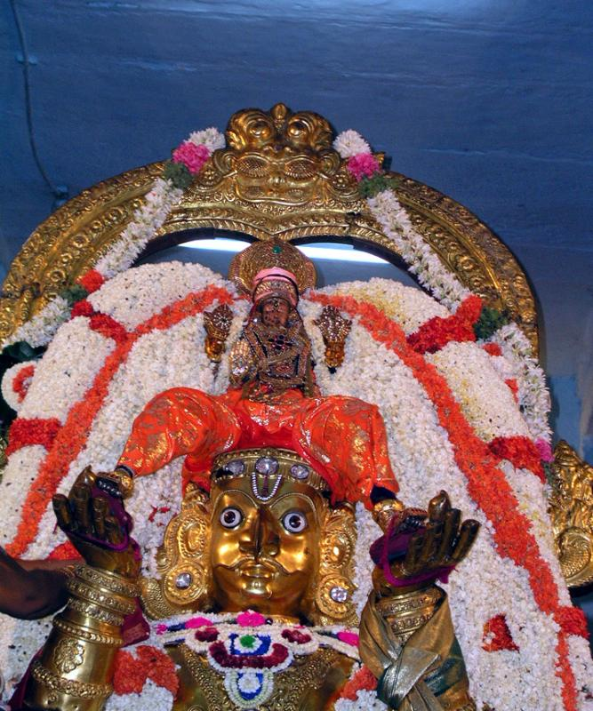
With the grace of Lord Dwaraknath and with the blessings of Alwars and Acharyas

will be performed on Saturday, the 30th of December 2006 at Sri Krishna Temple Hall, Darsait as per the following schedule. All the Devotees are invited to take part in the function and get the blessings of the Lord.

PROGRAMME
6.00 pm - Beginning of the function
6.15 pm - Garudavahana procession.
6.45 pm - Tiruvandikappu (ending of procession)
7.00 pm – Sri Vishnu Sahasranama Chanting.
8.00 pm - Namasangirthanam. (Bhajans)
10.00 pm – Mangala Harathi & Tirtham.
