Chapter 8 – Transcendental

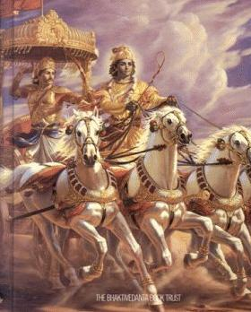
-Krishna tells about absolute, Spirit, Action, Matter, and the study of vedas in performance of
sacrifices, austerities and charities.
1. Answering all the queries satisfactorily and correctly is possible only by person of great wisdom.
2.Many people keeping mind to think of God, only during one's disease ,death or defeat is unfortunate.
3.Reality is the primeval resolve of God based on its growth from the seed sown by each individual.

4.Only true disciple is capable of understanding the full meaning of teachings from just an indication.
5.Remembrance of 'Truth' even at the last moment of life, will get equal rights and higher status.
6. Good thoughts help always, as thoughts of man just before death determines the form of next birth.
7.Remembrance of 'Truth' if constantly practiced then purification of heart is sure to happen.
8.Meditation helps the mind not to deviate even from a moment, in thinking of objects surrounding us.
9.God is the embodiment of pure existence ,absolute knowledge, subtle minded and arranger of everything.
10.Bhakthi or devotion till death is the supreme love for Truth ,necessary tool for our peaceful life.
11. True knower's of Vedas must also follow to find the Absolute Truth and lead a life of chastity.
12.Perfection,dedication and concentration is important to achieve success in any work.
13.Reality is only one without a second and can be attained by yoga concentration on 'Truth'.
14.By constant remembrance and thoughts of Truth, happiness in the world can be achieved completely.
15.Any person who possess maximum love and devotion, realize Truth and become free from rebirth.
16. Blessings of the Almighty are not subjected to any influence of time, region, person, mode or history.
17.When the worlds are transitory ,enjoyments are fleeting, the reality about Time is important factor.
18.All beings are connected in different ways with gross form of nature according to their 'karmas.
19.Everyone should know that Nature and Truth are ever in existence, visible and are not new one.
20.Don't attempt on evils or bad works even though such works are done by some people out of ignorance.
21. Truth does not differ ,though some sincerely practice with dedication in various disciplines.
22.Absolute surrender to God is the best as HE is sustaining all.
23.Take the correct path after identifying between right and wrong at the appropriate time.
24.Salvation is not based on time, season of death , but certain to persons who have realized the Truth.
25.Performance of duties devoted to action ,are sure to be protected from all natural threats.
26. Repeated Performance with expectation of return is not perfect ,whereas one without desire is ever good.
27.Devotion by striving constantly to realize the Truth is ever recognized and rewarded .
28. Studies for knowledge, performance of duties austerities and charities attain meritorious fruits.
HARE KRISHNA HARE KRISHNA KRISHNA KRISHNA HARE HARE

