Chapter 15 – Ultimate.
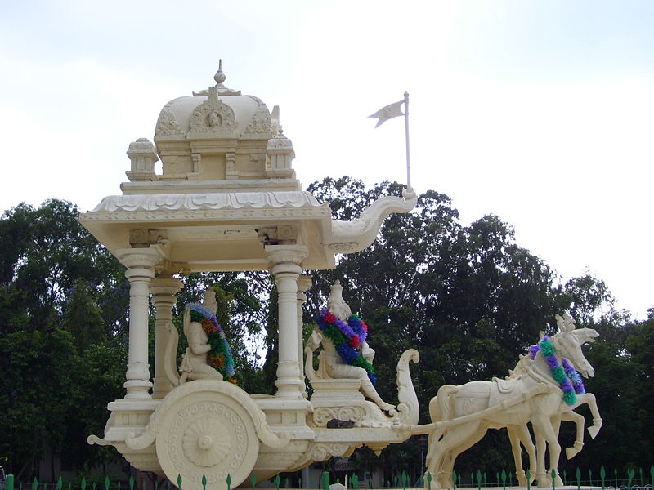

- Krishna discusses essential characters of the Supreme God and claims that services done under the proper guidance of a bona fide master, are not liable for ignorance or failure.

1. Reflection of spiritual world is situated on desire , just as a tree's reflection is situated on water.
2.Different modes of nature develop different senses, and by senses one enjoys varieties of sense objects.
3.Learn detachment through studies of spirituality with knowledgeable person and from scriptures.
4. Man should take untiring efforts for God realization and should take refuge in Him alone.
5. Spiritual knowledge is sure to yield when one is free from false prestige ,illusion and lust.
6. Spiritual world have no specific sunshine, moonshine or stars as they are always illuminated.
7.When mind is in goodness, activities are good, in passion it is troublesome and in ignorance it is bad .
8. Individual soul is just transmigrating, but present body and activities are background of next body.
9.Consciousness must be kept pure always; otherwise it will affect all future births.
10.Realise that Spirit is different from body and is changing its body and enjoying in different ways.
11. Persons engaged in pure devoted service sincerely are sure to achieve self-realization.
12.No one can claim of splendor of sun, moon, and fire, as their aim, as they are only God's creations.
13. Our minds must be firm in God as He is omnipotent and omnipresent and He only saves us all.
14. God only helps us in every aspect of our life and in various forms of our foodstuff.
15. All our actions are well noted and well remembered by the Supreme God, though we forget them.
16. Though there are fallible and infallible classes of beings, spirituality minded people never fail.
17.Wise man knows well that God gives them all the facility of enjoyment according to different works.
18. Only Great people with all exemplary qualities are considered as greatest person and are celebrated .
19. The wise man who realize Truth can constantly follow and achieve success without any doubts.
20. Services done under the proper guidance of a bona fide master, is not liable for ignorance or failure.

HARE KRISHNA HARE KRISHNA KRISHNA KRISHNA HARE HARE

