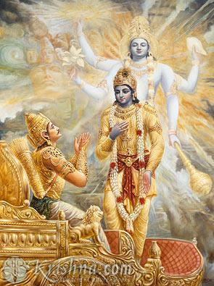
Chapter 13 – Nature.
-Krishna starts from difference of body and soul as 'field' and 'knower of field' and highlights the glory, reward, and the process of worship of God with its results .
1. Knowledge with Good education including study of natures from a renowned teacher is ever appreciable.
2. A conditioned soul can understand that he is different from the living body which is temporary one.
3. One should know that his knowledge is finite unlike the infinite one of the Supreme Almighty.
4. God alone knows about what changes in body will be taking place in the next moment, hour, day, or year.
5. Truth should be analyzed in depth according to cause and effect and should be strictly adhered to.
6. False ego and hatred must be avoided first in order to become a lovable person in the world.
7.Control of all our ten senses, desire and mind is must, otherwise it will cause decay and vanish .
8. Qualities of humility, pridelessness, nonviolence, tolerance and simplicity elevate man as a great one.
9. Cleanliness, steadiness, and self-control pave way for renunciation of objects of sense gratification.
10.Different treatment for happy and unhappy events and entanglement with kith and kin are to be avoided.
11. The object of true knowledge is Truth and other things are only ignorance and subordinate to this.
12. Philosophical search for absolute Truth and importance of Self-realization are good qualities.
13.Life should be for glorious achievements in this birth and to pray for not to have any more births.
14. Existence of God is identified in all places, at all times, by all means, and in all possibilities.

15. The excellence or superiority is known once Truth is identified easily, with revered approaches.
16. People even if divided in region, country, creed, or color have to be undivided in spirit.
17. Darkness and ignorance do not exist near the intellectual people at all times in this world.
18. There are many accessories to gain knowledge and there is no upper limit for gaining knowledge.
19. Good characters are to be followed as inborn like the nature, which has no beginning.
20. Nature alone generates cause and effect, and the individual soul is the source of enjoyment or sorrow.
21. Association with good people and movements always bring a person in good characters and natures.
22. God resides in the heart of all people, giving prompt advice to those who seek for their welfare.
23. Understanding nature and its qualities perfectly are the blessed one and free from next births.
24. Meditation, right action and perfect knowledge helps in realizing what the supreme nature is.
25. Knowledge received from the men of wisdom who have realized Truth is revered by one and all.
26. Production of all beings in many shapes and forms is only as a result of the union of matter and spirit.
27. Real understanding is seeing true nature of supreme as imperishable amidst the perishable beings.
28. Truth is equally present anywhere and so the equal treatment between the human being is ever good.
29. It is better not to proclaim any natural events as their own activity or as personal achievement.
30. All diversified forms of truth if known to one, is sure to attain liberation, ied in all places, at all times, by all means, and in all possibilities.
31. When right action is done without any selfish motive, contamination is not possible at all.
32.Good characters and actions are always not tainted like ether, present in air, water, fire and earth.
33.As one sun light up the entire universe, one spirit infuses life and activity into the whole world.
34. Real wisdom knows the difference between the constant and variables that are subject to changes.

HARE KRISHNA HARE KRISHNA KRISHNA KRISHNA HARE HARE

