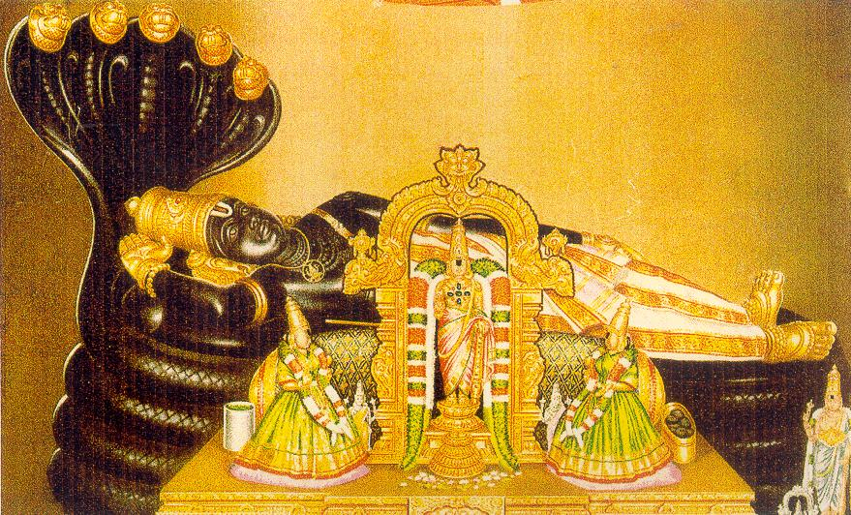 | 

Sri Ranganatha Temple
Sri Ranganatha Seva Samithi, Inc.
(Regd. Non-Profit, Tax Exempt, Religious Organization)

8 Ladentown Road, Pomona, NY-10970 (Phone: 845-364-9790)
www.ranganatha.org

Board of Trustees

Venkat Kanumalla
Chairman: 845-627-6716

Janakiram Prasad
Secretary: 845-323-4108

Hemwati Panhani
Treasurer: 718-740-4332

Bharathi Hodarkar
Joint Treasurer: 845-354-6202

Trimbak Bharati:
845-623-0345 : Fund-Raising Committee Chairman.

B.Dwarakanath:
845-638-4220 : Maintenance Committee Chairman

Murthy Ayyala:
631-689-8927: Religious Committee Chairman

Radhika Murali:
201-666-0345

Gurunath Pagala:
845-268-4942

Sampath Rengarajan:
734-332-1272

Ramu Surapaneni:
845-639-6977
On behalf of our MahadAchAryas, Bhagavat Sri RAmAnuja, Sri NigamAnta-MahA-Desika, the First & the 44th pattam Srimat Azhagiyasingars, the Devotes, Volunteers & the Board of Trustees invite you all, to attend the SATAABHISHEKAM Celebrations of:
H.H. the Present 45th Jeer of Sri Ahobila Mutt
Srimate Sri Lakshmi-Nrusimha Divya Paduka Sevaka Srivan Sathokopa Sri NArAyaNa Yatindra Mahadesikan
on Nov 29th, 30th, Dec 1st, Dec 2nd and 3rd , 2006
& receive the blessings of Sri RAmAnuja, Sri Vedanta-Desika, the 1st, 44^{th &} 45th Jeers, Sri Maaloola & the Divya Dampatis..

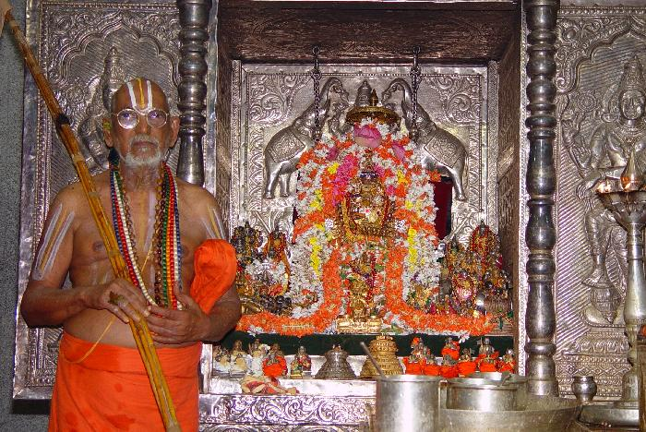

Program:

Nov 29th: Ekanta Tirumanjanam at 10 AM,

Nov 30th: Special Tirumanjanam at the Feet of Sri Ranganatha at 10 AM Dec 1st: Special maryaada at Sri Maha Lakshmi Sannidhi at 8 PM;

Dec 2nd, and 3rd: Veda & Prabandha Paarayanam, Utsavam and Special Maryada at all Sannidhis to H.H. Srimad Azhagiyasingar ( it is H.H. wish & command that we all celebrate the Satabhisheka mahotsavam with His own Archa Murthy at Sri Ranganatha Temple, if we can not be there in India with His Nija Murthy ).

