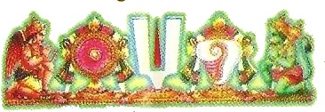
Arulmigu kalamega perumal temple,

thirumohur, Madurai-625107(t.n)
History of the thirumohur, mohanakshetram
Mohini avatara
Thirumangai Alwa
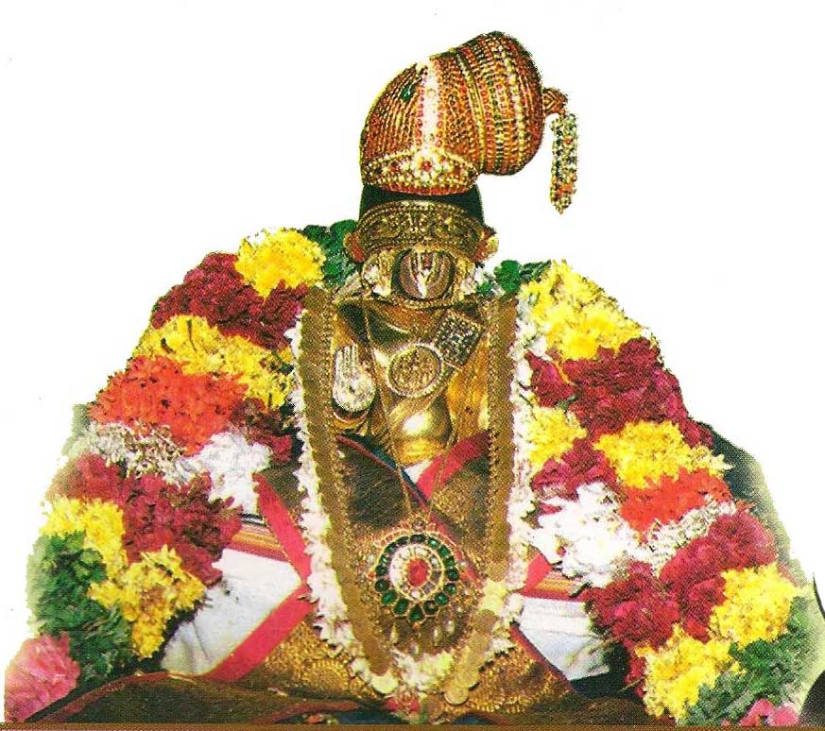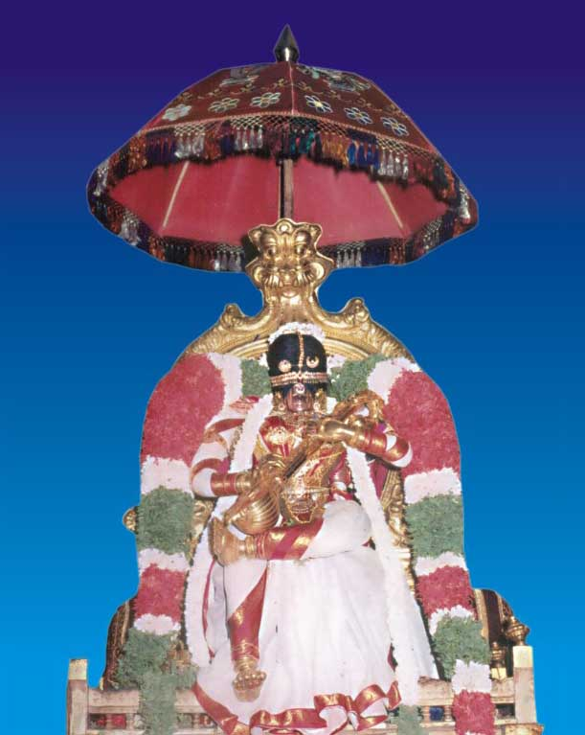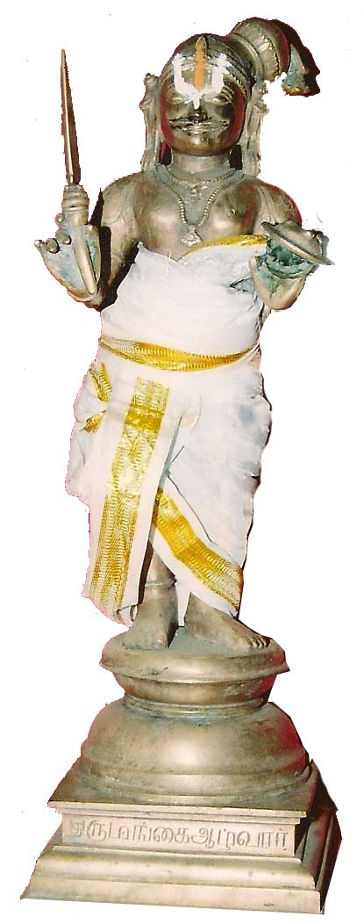
Nammalwar Mohini avatara Thirumangai
Alwar

Thirumohur is a small town located at north east of Madurai at a distance of 12 kilometers on the Madurai Melur road. The temple was renovated and expanded by 1st pandiya emperors to king Krishna devarayor and Siva Ganga - Maruthu Pandi brothers. From the inscriptions available, it has been reported that the temple was built around 7 century. The idols are reported to be more than 5000 years old. It is a well known legend that Lord Vishnu took the Mohini avatara i.e., assumed the form of a beautiful maid, to trick demons for distributing the divine nectar (Amirtham) to Devas. Thirumohur belongs to the pancharatra agama and is one of the 108 Divya Desams in the vaishnavite tradition. Nammalwar and Thirumangai Alwar have written in praise of this temple.

Thirumohur, Madurai, has its legendary origin in the distant past when devas and asuras churned the ocean to ger amirtham (nectar), a sip of which would ensire immortality. When the pot of nectar surfaced, vishnu, in the form of mohini (the charmer), took it away, and while the asuras stood mesmerised by her beauty, distributed heavenly nectar or amrutha to the devas in this place. When the asuras tried to stand among the devas, in order to get a share, Surya and Chandra identified them, where by their heads were replaced by snake's heads and they became rahu and kethu. So this is a place where pariharams may be offered to rahu and kethu. The puranic name of Thirumohur – Mohanashetram – Confirms the incident.
Namamalwar and Thirumangai Alwar have glorified this place in their hymns and hence this place is worshipped as Divya Desam by the devotees. Thirumohur is one of the 108 Divya Desams situated East of Madurai at a distance of 12 kilometers. It is surrounded on all sides by lush vegetation, paddy feilds and the small hill called as Yanai Malai. The Deity in this shrine is send to have guided Nammalwar in the Divine pathway known as called Archiradi Gattu. Hence the deity is also called by the Name " Marganbandu"
The Moolavar is Kaalamega Perumal seen in standing posture - right hand - varada hastam, gadai (mace) in left hand facing east. The utsavar is Thirumogur Aapthan with pancha ayudham (five weapons). . There is a gold kavasam for Aadiseshan. There is a sannithi for Palli Konda Perumal or Ksheerabthi nath, who is worshipped by Sridevi and Bhoomidevi. This is known as prarthanasayanam. This is called as Sukra sthalam, as the devis had worshipped Sriman Narayana, who had then retrieved the wealth of the devas by destroying the asuras.
The holy Vimana is known as Chaturmoka Vimana. The temple complex was build by Pandyas Vijaya Nagara Emperor and Nayak Chraftains during thier sucession region. Then one more life like status of Marudu Brothers and constructed the front Mantap. This are beautiful senlptors in the pillars of Garuda Mantapam, Rama with his brother Lakshmana and Sita in his exile is beautifully portrayed as scultpates, there Manmathan and Rathi are rare pieces in this hall.
Thaayaar - Mogurvalli (Mohanavalli, Megavalli).

Theertham - Sheeraapthi Pushkarini.

Mangalasasanam:
Nammalwar - 3667-3677. Thirumangaialwar - 2673 (74)
Inscriptions
There are pieces of inscriptions belonging to the periods of Sundara Pandya (1251 - 1271 A.D.) Kulasekara Pandya I ( 1268 -1311 A.D.) and Sadaya Varman Sundara Pandy ( 1304 - 1319 A.D.)

Arulmigu kalamega perumal temple,

thirumohur, Madurai-625107(t.n)
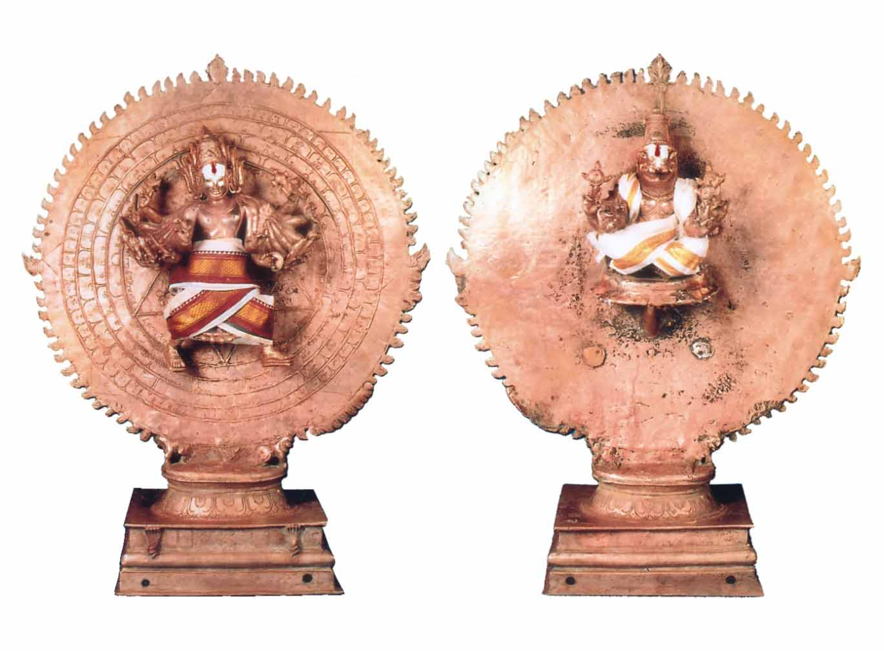
Sri narasimma sudharsanam
There is a separate shrine dedicated to Sri Surdarsana Murthy (Chakrathazhvar) by Jadavallaba Srivallaban in A.D.1251.
In this sacred spot, Chakrathazhvar is in the form of the moving chakra, and has the letters to as the mantra, as per the agama rules. The Lord has 16 divine hands and is armed with 16 types of weapons with a third eye on the forehead and Jwala kesham. His feet are (prathyalidham) shaped as if they were running, in order to eliminate the hardships of the devotees.
On the rear side of the moolavar and urchavar statues is the Yoga narasimhar statue, with four kinds of chakrayudams in his four hands; representing dharma, artha, kama and moksha.
Success and progress are achieved by all those who worship here such as Abhamrutyadosa Nivarana, Grahadosa Nivarana, Be getting good children, Bodily health, Trade development and sowbaghya in all fields will be bestowed by the grace of lord Chakkarathalwar and Narashimma

LET US JOIN TOGETHER ON THIS NOBLE CAUSE………..

YOU ARE EARNESTLY REQUESTED TO PARTICIPATE IN THE HOLY THIRUPPANI BY CONTRIBUTING GENEROUSLY.

Contact person and address for renovation
S.sridhar batter S.GOPAL BATTER
Secretary - cell: 98420-24866 Secretary –cell: 99423-26069
Sri Lakshmi Narasimha Apthan Kaingarya Sabha,
1/8, East Mada Street, Thirumogur,
Madurai District,
TamilNadu – 625107.
EMAIL ID : sri_yoga_narashimma@yahoo.com

Committee Member
D.D.JAYARAM.
CELL; 98422-06760
EMAIL ID : ddjayaram@yahoo.co.in

Nammawar

