SWAMI DISKAN
******************************************************************************

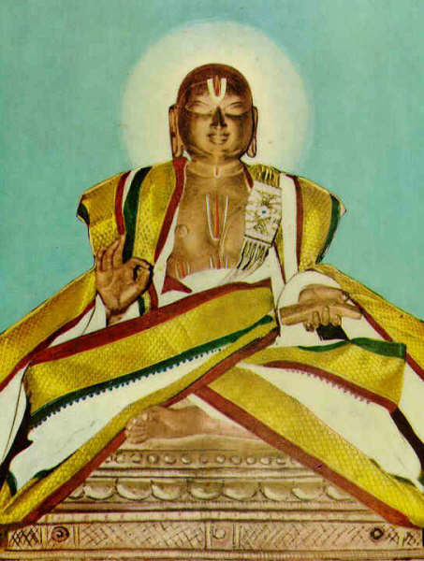

SRI VENKATANATHA OR VEDANTHA DESIKA TO USE THE NAME BY WHICH HE IS MORE COMMENLY KNOWN WAS BORN AT THOOPPUL A VILLAGE NEAR KANCHIPURAM IN 1268 A.D. HIS FATHER SRI ANANTHA SOORI AND HIS MOTHER THOTHARAMBA. HIS MATERNAL UNCLE WAS RENOWNED APPULLAR . WHOSE REAL NAME WAS RAMANUJA . IT IS UNDER HIM SWAMI LEARNT THE SASTHRAS. APPLULLAR HAD STUDIED VEDANTHA UNDER NADATHUR AMMAL ( VARADACHARYA ) ALONG WITH SUDARSANA BHATTA.
APPULLAR WAS THE GREAT GRAND SON OF PRANATHARTHIHARA, THE DECIPLE OF SRI RAMANUJA. SWAMI SEEMS TO HAVE ATTRACTED THE NOTICE OF NADATHUR AMMAL IN HIS AGE OF FIVE . BEFORE THE AGE OF 20 HE ACQUIRED A MASTERY OF ALL THE LEARNING CURRENT IN HIS DAYS NOT ONLY IN RELIGION BUT IN SECULAR SUBJECTS AS WELL. SWAMI BECAME SO PROFICIENT IN THE COMPOSITION OF POETRY AND IN THE MASTERY OF THE SCIENCE OF LOGIC THAT HE CAME TO BE CALLED " KAVITHARKIKA SIMHAM " ( LION AMONG THE POETS AND LOGICIANS ). FOUR HOLY PLACES ARE ASSOCITED WITH SWAMI. THEY ARE THIRUVAHEENDRAPURAM, IN SOUTH ARCOT; KANCHIPURAM NEAR CHENNAI; SRIRANGAM THE CENTRE FOR VAISHNAVITE CULTURE AND AND HE SPENT SOME YEARS IN SATHYAKALAM A SMALL PLACE NEAR MYSORE IN KARNATAKA STATE. IT IS SAID THAT HE WENT ON PILGRIMAGES TO NORTH INDIA. IT WAS PROBABLY AT THIRUPATHI THAT HE COMPOSED " DAYA SATHAKAM ". IT IS SAID THAT HE VISITED ALSO MATHURA, BRIDAVAN, AYODHYA AND BENARAS. SWAMIGAL CHOSE TO LIVE A LIFE OF POVERTY . BY HIS EXTRAORDINARY LEARNING AND EXEMPLARY WAY OF LIFE HE WON THE ADMIRATION AND REVERENCE OF ALL THOSE WHO WERE SPIRUTUALLY MINDED. HE WAS BLESSED WITH LONG LIFE AND ATTAINED PARAMAPADA IN 1369 A.D.
**********************************************************************************

