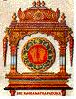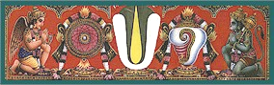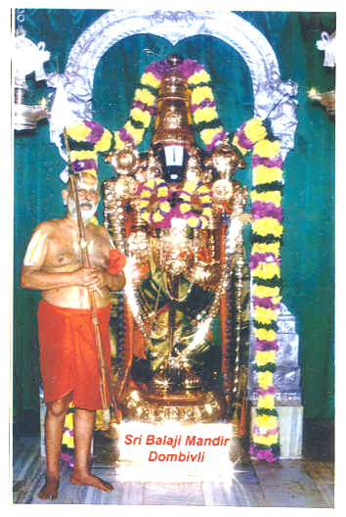
Srimathe Ranga Ramanuja Mahadesikaya Namaha
Srimathe Srinivasa Ramanuja Mahadesikaya Namaha
Srimathe Vedantha Ramanuja Mahadesikaya Namaha
Sri Bhoomineela Padmavathi Naayika Sametha Sri Srinivasa Parabrahmane Namaha
SRIRANGAM SRIMAD ANDAVAN PERIASHRAMAM
SRI BALAJI MANDIR
(Paschim Tirupathi)
GOGRASWADI, DOMBIVLI EAST 421 201. TEL : (0251)2453081
E-mail : ssapsbm@yahoo.com
S. NARASIMHA RAGHAVACHARIAR R. RAJAGOPAL V. RANGANATHAN, I.A.S.
Srikaryam / Chairman, Ex. Chief Secretary, Govt. of
Vice President National Executive Committee Maharashtra, Patron-in-Chief

Silver Jubilee Year – Sri Sudarshana Jayanthi
Sunday the 24th June, 2007.

Sri Balaji Mandir established by Srimath Sri Vedanta Ramanuja Mahadesikan (Sri Thirukkudanthai Andavan) in the year 1982-83 is celebrating its Silver Jubilee during this year 2007 – 08. As per the Niyamanam of His Holiness Srimath Sri Ranga Ramanuja Mahadesikan, this year we are celebrating all functions in a grand befitting manner. The Silver Jubilee celebrations will culminate with Brahmotsavam in January 2008.

The Mandir, widely acclaimed as Paschim Tirupati, bestows pleasure and immense satisfaction to his devotees as at Tirupati and has carved a great niche and is creating its own image and fame in contemporary time.

During this Silver Jubilee auspicious year, we are planning to celebrate Sri Sudarshana Jayanthi which falls on Sunday the 24th of June, 2007, with a grand Sri Sudarshana Sadakam (written by Swamy Koora Narayana Jeeyar) Homam with 108 Kalasams, followed by Thirumanjanam and Porappadu in the evening.

The Sudarshana Chakram is the mighty weapon of Lord Narayana and has many auspicious attributes associated with it. Most importantly, it has the attributes of "Pida Pradanam" which gives immediate relief from pain and sufferering to the seeker/performer. The Sudarshana Chakram also has the attribute of "Papa Nashanam", i.e., the destruction of sins. This is the first step to be adopted in the realization of God (Lord Narayana). Swami Desikan most eloquently summarizes the characteristics of the mighty Chakram in both the Sudarshana Ashtakam as well as the Shodasayudha Stotram. The mighty Jwala is the aspect of Jwala Nrisimhar who destroyed Hiranyakashipu and therefore, is resident in the Sudarshana Yantram. Thus, offering prayers to Sudarshana Chakram is equivalent to offering prayers to the entire Dashavataram. Great scholars seek the support of the Chakram before engaging in debates as can be seen from Swami Desikan's Sudarshana Astakam (Pratita Vidwat Sapakshita). The Sudarshana Chakram has healing characteristics. Therefore performance of the Sudarshana Homam gives relief from afflictions of fever and even possession by the mighty Brahma Rakshasa. A legend has it that Swami Desikan composed the Sudarshana Astakam to help the people of a village stricken by the plague epidemic. As soon as Swami Desikan finished his composition, the epidemic was over.

Srimathe Ranga Ramanuja Mahadesikaya Namaha
Srimathe Srinivasa Ramanuja Mahadesikaya Namaha
Srimathe Vedantha Ramanuja Mahadesikaya Namaha
Sri Bhoomineela Padmavathi Naayika Sametha Sri Srinivasa Parabrahmane Namaha
SRIRANGAM SRIMAD ANDAVAN PERIASHRAMAM
SRI BALAJI MANDIR
(Paschim Tirupathi)
GOGRASWADI, DOMBIVLI EAST 421 201. TEL : (0251)2453081
E-mail : ssapsbm@yahoo.com
S. NARASIMHA RAGHAVACHARIAR R. RAJAGOPAL V. RANGANATHAN, I.A.S.
Srikaryam / Chairman, Ex. Chief Secretary, Govt. of
Vice President National Executive Committee Maharashtra, Patron-in-Chief

The performance of the Sudarshana Homam grants the performer health, wealth and prosperity. If the performer seeks spiritual benefits, while performing the Homam, he gets it. If the person seeks material benefit, he is blessed with all riches upon conclusion of the Homam.

In this mundane life of Mumbai where devotees are not able to perform any spiritual activities at home, we are giving an opportunity to devotees to participate and take the blessings of Sri Sudarshana on his Jayanthi day by partaking in the Maha Sudarshana Sadaka Homam, the Thirumanjanam and the Porappadu overwhelmingly.

The devotees who would like to take advantage of participating in this Maha Homam are requested to contact the office:

Full Day Ubhayam Rs.5001/-
The Small Kalasam each Rs. 501/-

We have kept the sponsor charges to the barest minimum so that people at large can participate in the same. Kindly participate with full family in the Homam, Thirumanjanam and evening Porappadu and take the Blessings of Lord Sri Sudarshana and Lord Sri Balaji and Srimad Andavan.

Dombivli East
04.06.2007 Managing Committee

