Chapter 12 – Devotion
**************************************************************************
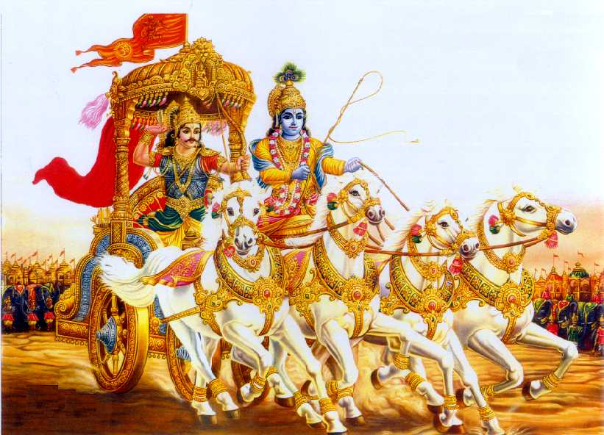
- Krishna indicates Arjuna, the process of yoga solely devoted to Him ,with merits of worshippers and the means of God realisation and also to avoid the selfish feelings.
1. Devotion is nothing but dedicated service with supreme faith and love irrespective of its nature.
2.We are all basically dependents, to the Supreme and He is the one who is completely independent.
3.Worship GOD with firm control of mind and full control on senses for the welfare of our own people.
4.Supreme is unthinkable, indestructible, indefinable, eternal, immovable, omnipresent and omnipotent.
5. Absolute truth, knowledge and bliss involve strain in the initial stage, but it helps him later.
6. Absolute surrender to supreme is just chanting, praising the glory with single minded devotion.
7. When the mind and the intellect merged once for all in Truth , there is no fear of death at all.
8. Full faith on only one, will definitely cause compassion, omniscience, cordiality and amiability.
9. Many spiritual disciplines are available, only to those who could not fix mind and intellect on Truth.
10.Performing any loyal action for the sake of Truth is equally good and are not inferior to devotion.
11.Renunciation of fruit of actions , is also a type of dedication , and it shows a good faith only.
12.Man's desire and attachment have to be totally eradicated from the mind first, to obtain full peace.
13.Hatred towards anybody is not to be encouraged at all times, and forgiving is always the best.
14.Contentment in life is a sort of self control and discipline, and so it is liked by all people.
15.Do not be carried away by annoyances to fellow creatures, which cause suffering ,agony or fear .
16.Impartial ,pure, clever people have no wants at all, and so they are ever loved by one and all.
17.Sinful acts are not possible to the people who have no likes and dislikes, and who hate nobody.
18.There are no faults, adulterations and biased natures if acts to friends or foes are balancing one.
19.Neither delighting in praise ,nor lamenting over reproach ,makes the people and situation stable.
20.Getting all privileges and facilities are sure, out of dedicated, sincere and faithful service.

HARE KRISHNA HARE KRISHNA KRISHNA KRISHNA HARE HARE

