Dear Devotees,

Wish You a Very Happy Deepaavali.

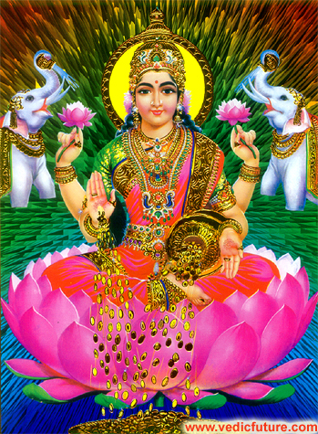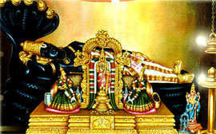

May the Choicest Blessings of the Divya-Dampatis –
Sri Maha-Lakshmi and Lord Sri Ranganatha
be showered on You
and Your loved ones Always on this auspicious Deepaavali day.

With Sincere Regards and Blessings,

Yours Truly,
In the service of the Divya-Dampatis,

Sridhar Dikshit
( also known as Venkat Kanumalla )

