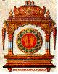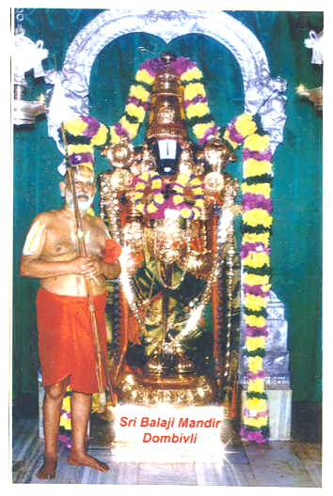
Srimathe Ranga Ramanuja Mahadesikaya Namaha
Srimathe Srinivasa Ramanuja Mahadesikaya Namaha
Srimathe Vedantha Ramanuja Mahadesikaya Namaha
Sri Bhoomineela Padmavathi Naayika Sametha Sri Srinivasa Parabrahmane Namaha
SRIRANGAM SRIMAD ANDAVAN PERIASHRAMAM
SRI BALAJI MANDIR
(Paschim Tirupathi)
GOGRASWADI, DOMBIVLI EAST 421 201. TEL : (0251)2453081
E-mail : ssapsbm@yahoo.com
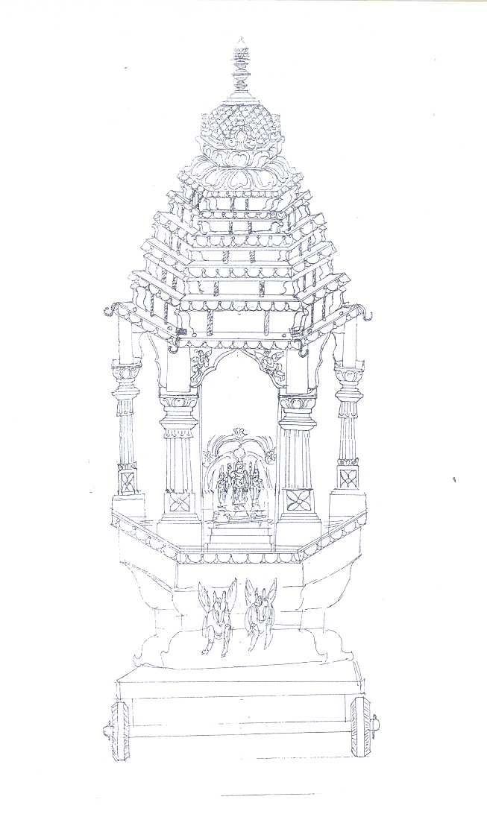
RATH (CHARIOT) FOR SRI PADMAVATHI THAAYAR

Sri Balaji Mandir, Dombivli has been widely acclaimed as Paschim Tirupati by devotees of all walks of life, who participate with great enthusiasm in the activities of the Temple. Lord Sri Balaji bestows pleasure and immense satisfaction to his devotees as in Tirupati. Rituals are being performed according to aagama sastra codes as enunciated by Sri Ramanuja - Strotra-Patanam, Veda Patanam, Aradhanas throughout the day, distribution of anna-prasadam to all devotees twice daily, festivities – monthly, annual and on special days – these are all the special features of this Temple. The Mandir has carved a great niche and is creating its own image and fame in contemporary time.

By the grace of Sri Bhoomineela Padmavathi Sametha Lord Sri Balaji and the blessings of our Guru Parampara, the Annual Brahmothsavam is being conducted every year, coinciding with the Prathishtapana Day i.e. day of Pushya Nakshatra in the month of Thai (January/February), in a grand manner. Last year we celebrated the silver jubilee year of the Temple. Devotees had supported overwhelmingly in making a big chariot for Sri Balaji.

Every year we celebrate the Avathara Dhinam of Sri Padmavathi Thaayar, in the month of Karthigai (November / December) with Thaayar Utsavam for 5 days. This year the Utsavam is starting on Friday the 28th of November, 2008 and culminates on Tuesday the 2nd of December, 2008, being the Avathara Dhinam of Thaayar. On this auspicious day, His Holiness Srimadh Aandavan wishes that a small chariot / Rath for Thaayar be made and taken around inside the Temple.

To fulfill the desire of His Holiness, we earnestly solicit the support of all devotees in making a small chariot for Sri Padmavathi Thaayar before November, 2008. Cheque / Demand Draft payable at Mumbai / Dombivli be drawn on SSAP SRI BALAJI MANDIR

In the service of Sri Balaji and HH Srimadh Aandavan

