Carolina Israelite Author Events
Carolina Israelite
How Harry Golden Made Us Care about Jews, the South, and Civil Rights
by Kimberly Marlowe Hartnett
368 pp., 20 illus., notes, bibl., index
ISBN 978-1-4696-2103-6 $35.00 cloth
Publication date: May 11, 2015
For more information: http://uncpress.unc.edu/books/T-8054.html
For a selection of publicity materials for media use, including a jacket, fact sheet, and author Q&A, please go to www.ibiblio.org/uncp/media/hartnett/

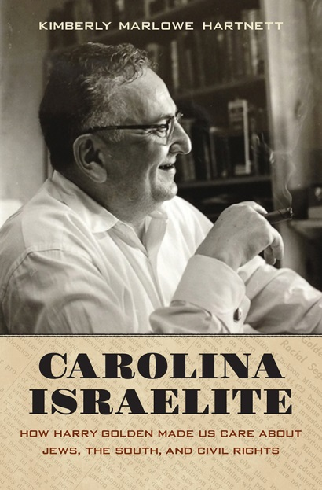
West Coast Events
- Wednesday, May 13, 2015 7:00 PM
Congregation Beth Israel
Portland, OR
- Tuesday, May 19, 2015 7:00 PM
University Book Store
Seattle, WA

NC Events
- Sunday, May 31, 2015 7:00 PM
Lerner Hall, Jewish Community Center
Charlotte, NC
(sponsored by the Charlotte-Mecklenburg Library)

- Monday, June 1, 2015 7:00 PM
Regulator Bookshop
Durham, NC

- Tuesday, June 2, 2015 7:00 PM
Quail Ridge Books
Raleigh, NC

