

February 2017

***Presidents’ Day is Feburary 20, 2017!***

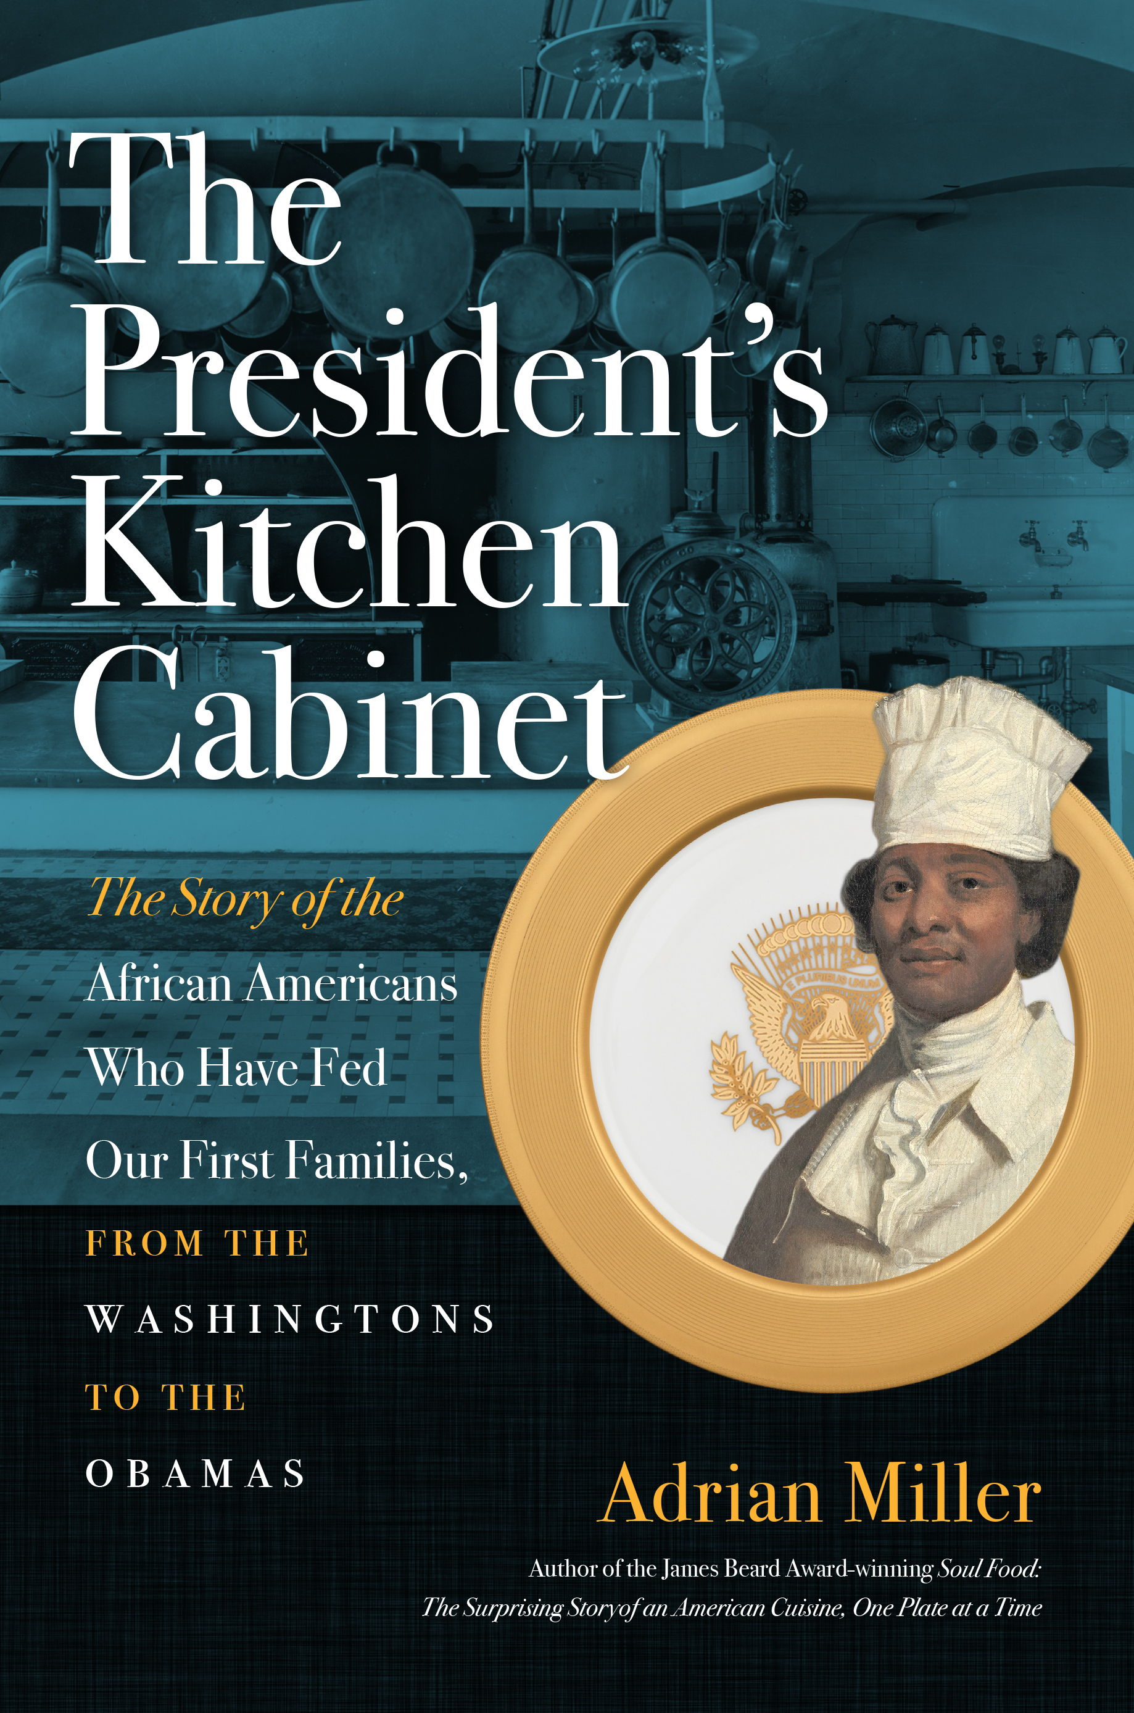**Review Copy**

**The President’s Kitchen Cabinet**

The Story of the African Americans Who Have Fed Our First

Families, from the Washingtons to the Obamas

by Adrian Miller

296 pp., 12 color plates, 24 illus., notes, bibl., index

ISBN 978-1-4696-3253-7 $30.00 cloth

Publication date: February 20, 2017

For more information: <http://uncpress.unc.edu/books/13626.html>

Author’s website: [http://adrianemiller.com](http://adrianemiller.com/" \t "_blank)

**For a selection of publicity materials for media use, including a jacket image and promotional recipes, please go to** [**http://www.ibiblio.org/uncp/media/miller\_presidents/**](http://www.ibiblio.org/uncp/media/miller_presidents/)

James Beard award–winning author Adrian Miller vividly tells the stories of the African Americans who worked in the presidential food service as chefs, personal cooks, butlers, stewards, and servers for every First Family since George and Martha Washington. Miller brings together the names and words of more than 150 black men and women who played remarkable roles in unforgettable events in the nation’s history. Daisy McAfee Bonner, for example, FDR’s cook at his Warm Springs retreat, described the president’s final day on earth in 1945; he was struck down just as his lunchtime cheese soufflé emerged from the oven. Sorrowfully, but with a cook’s pride, she recalled, “He never ate that soufflé, but it never fell until the minute he died.”

A treasury of information about cooking techniques and equipment, the book includes twenty recipes for which black chefs were celebrated. From Samuel Fraunces’s “onions done in the Brazilian way” for George Washington to Zephyr Wright’s popovers, beloved by LBJ’s family, Miller highlights African Americans’ contributions to our shared American foodways. Surveying the labor of enslaved

**[more]**



people during the antebellum period and the gradual opening of employment after Emancipation, Miller highlights how food-related work slowly became professionalized and the important part African Americans played in that process. His chronicle of the daily table in the White House proclaims a fascinating new American story.

Adrian Miller—author of *Soul Food: The Surprising Story of an American Cuisine, One Plate at a Time*, which won a James Beard Foundation book award—worked as a special assistant to President Bill Clinton. He is a certified Kansas City Barbecue Society judge and former Southern Foodways Alliance board member. He lives in Denver, Colorado.

###

**Praise:**

“For food history and presidential history buffs alike, both entertaining and illuminating.”

—***Kirkus Reviews***

“An intriguing glimpse into the inner workings of the White House kitchen and the chefs who have made its wonderful cuisine possible.”—***Library Journal***

“Miller opens a door into a fascinating world that few ever think about: the White House kitchens. There, he brings to light a realm shaped by an often-ignored group of African Americans who have nurtured the first families so they could lead a nation.”—***Booklist***

**Promotional recipes are limited to the following with the credit line below:**

* *Caroline Harrison’s Deviled Almonds* p. 124
* *Hawaiian French Toast* p. 159
* *Jerk Chicken Pita Pizza* p. 160
* *White House Eggnog* p. 186

From The President's Kitchen Cabinet: The Story of the African Americans Who Have Fed Our First Families, from the Washingtons to the Obamas. Copyright © 2017 by Adrian Miller. Published by the University of North Carolina Press. Used by permission of the publisher. www.uncpress.unc.edu

**Please contact Gina Mahalek at (919) 962-0581 or** [**gina\_mahalek@unc.edu**](mailto:gina_mahalek@unc.edu) **to request permission to use any additional recipes.**