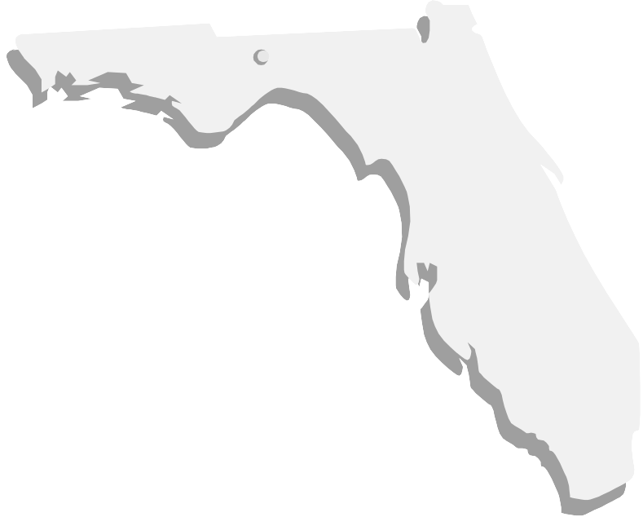
FNLA 2002

The Florida News Librarians' Association
invites you to attend the annual FNLA meeting
Friday, May 24
at The Tampa Tribune/WFLA Channel 8
& Tampa Bay Online News Center.

Registration Fee: $20 ($10 for students)


Sponsored by
and

Program:

8:00-8:30 Continental Breakfast
8:30-9:00 Annual FNLA Business Meeting
9:00-11:30 Multimedia Convergence and tour of The Tampa Tribune,
Presented by Jody Habayeb
11:30-1:00 Lunch
1:00-2:30 Changes in public records laws
Presented by Barbara Petersen of the First Amendment Foundation
2:30-4:00 Public information resources
Presented by Joe Adams, author of Florida Public Records Handbook

The Tampa Tribune is located at 200 S. Parker Street, Tampa FL 33606

A special rate is available for Thursday night (5/23) at the Radisson Riverwalk Hotel, which is just a 5-minute walk over the bridge from the Tribune. Rates are $89/single city view & $99/single river view. Call 813-223-2222 and mention you’re attending the FNLA function for the special rate.

Please return registration form & check made payable to SLA/News Division by May 1, 2002 to: Megan Gallup, The Daytona Beach News-Journal, 901 Sixth Street, Daytona Beach, FL 32120.

Questions?

Megan Gallup, (386) 681-2543, megan.gallup@news-jrnl.com
Jody Habayeb, (813) 259-7379, JHabayeb@tampatrib.com

----------------------------------------------------------------------------------------------------------------------------
FNLA 2002 Registration

Name: __________________________ Business/Organization: _______________________

Phone number: ___________________ E-mail address: _____________________________

Please share this invitation with your co-workers and others you think would benefit.

