
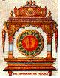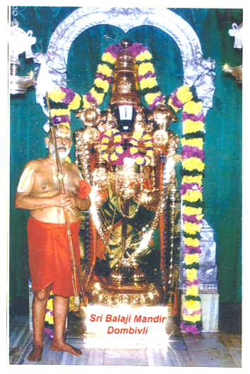
Sri
Srimathe Ranga Ramanuja Mahadesikaya Namaha
Srimathe Srinivasa Ramanuja Mahadesikaya Namaha
Srimathe Vedantha Ramanuja Mahadesikaya Namaha
Sri Bhoomineela Padmavathi Naayika Sametha Sri Srinivasa Parabrahmane Namaha

SRIRANGAM SRIMAD ANDAVAN PERIASHRAMAM
SRI BALAJI MANDIR
GOGRASWADI, DOMBIVLI EAST 421 201. TEL : (0251) 2453081
E-mail : ssapsbm@yahoo.com

2007 – 08 – SILVER JUBILEE YEAR
AN APPEAL FOR MAKING SILVER KAVACHAM
FOR MOOLAVAR SRI BALAJI

Sri Balaji Mandir, Dombivli, established in the year 1982-83 by Srimad Sri Thirukkudanthai Andavan, has been widely acclaimed as Paschim Tirupati by devotees of all walks of life, who participate with great enthusiasm in the activities of the Temple. Lord Sri Balaji bestows pleasure and immense satisfaction to his devotees as in Tirupati. Rituals are being performed according to sastric codes as enunciated by Sri Ramanuja - Strotra-Patanam, Veda Patanam, Aradhanas throughout the day, distribution of anna-prasadam to all devotees twice or more daily, festivities – monthly, annual and on special days - are all special features of this Temple. The Mandir has carved a great niche and is creating its own image and fame in contemporary time.

The year 2006-07 was more auspicious as during the year we celebrated the 100th Birth Centenary of Founder of the Temple, Srimad Sri Vedanta Ramanuja Mahadesikan (Thirukkudanthai Andavan).

This year 2007 – 08 we are celebrating the Silver Jubilee Year of the Temple and as per the Niyamayan of His Holiness Srimad Sri Srimushnam Andavan, that all functions / festivals should be celebrated in a befitting manner. His Holiness also desires that on this Silver Jubilee Year we must attire Moolavar Sri Balaji with full Silver Kavacham. The estimated quantity of silver that is required for the same works out to around 25 KGS.

All sishyas, devotees and well wishers are earnestly requested to contribute liberally in cash and IN KIND BY SILVER and strive to make the desire of His Holiness a reality. CHEQUE / DD MAY PLEASE BE DRAWN IN THE NAME OF ‘SSAP SRI BALAJI MANDIR’ DOMBIVLI.

Dombivli,
17/08/2007 Managing Committee

