CHAPTER – 5. - Renunciation

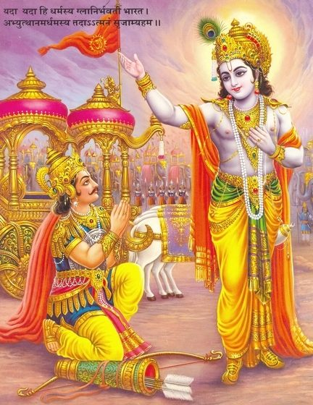

-Arjuna clarifies the doubt as yoga of action is better than yoga of knowledge. Also, when one is free from joy or sorrow, in feelings can easily be freed from bondage.

1.True wisdom is obtained by listening and performing every action without any selfish motive.
2.The practice of doing it in action is always found easier than the practice of getting its knowledge.
3.Worldly Bondage can be avoided by renouncing from any effects of joy and sorrow or good and bad.
4.After the performance of duties with sufficient knowledge and dedication ,fruit is sure to obtain.
5.When one firmly adhere the right path, though in different directions , it is definite to get success.
6.The performance of actions is always important consideration than renunciation or control of senses.
7.Conquering the mind ,mastering the senses ,and keeping the heart pure helps to be untainted for ever.
8.Different activities in a body are activated only after knowing the reality of things and happenings.
9.As the senses in a body play the major part ,control of all senses is vital one for a happy living.
10.Sins take place when mind is full of desires, and it will not be like lotus leaf when touched by water.
11.The feelings of me' 'Mine' and 'I' must be deleted from mind ,action, and thought of every individual.
12.When action is done with fully centered self interest, no one can call him as a noble person.
13.The control of the nine cavities of human body paves way for identifying Truth ,knowledge and bliss.
14.Activities are taking place according to nature alone and not the way, or on purpose of the same.
15.The virtues or sins of anyone is not taken out by anybody at any time, but will remain in tact with him.
16.Good knowledge obtained ,dispel our ignorance ,and helps in revealing the Truth of existence.
17.Knowledge along with dedication in following the same in good faith, makes person of excellence.
18.Various communities occur in society just to give knowledge and to educate culture ,and gentle conduct .
19.When Unity in diversity is established in mind , then it makes everyone happy in the whole world.
20.The wise man's intelligence should always be clear and be free from doubts, errors and infatuations.
21.Imperishable happiness is possible from yoga ,but not to one, when he is in the sense of enjoyment alone.
22.Intelligent people always realize well about the evils as source of sufferings, and avoid them totally.
23.A perfect and happy man is one who has no trace of lust, anger, and hatred throughout his life period.
24.When one forgets egoism and all evil propensities completely ,he will realize the Truth immediately.
25.Discipline,ideal behaviour, service motive and propagation of good principles are needed for peace.
26.Obstacles of distraction, impurity, and obscurity have to be completely removed for getting knowledge.
27.The process of exhalation and inhalation is to be regulated and made even through Yoga practices.
28.Meditation, helps one to be free from various likings as they only lead to the unnecessary worries.
29.Observation of sacrifices and ascetic practices which strictly follow the scriptures , bring peace.
HARE KRISHNA HARE KRISHNA KRISHNA KRISHNA HARE HARE

