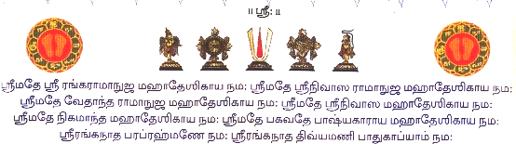
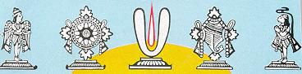
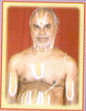
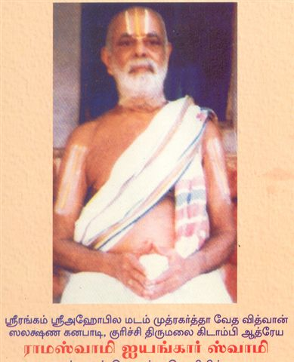
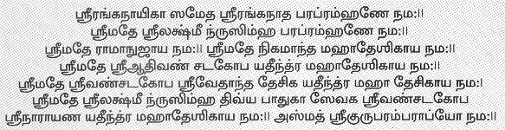
Sri U. Ve. Kuruchi Kidambi Athreya Lakshmi Narasimhachariar Swamy
Dear Bhaktas,
Sri.U.Ve.KuruchiKidambi Athreya Lakshmi Narasimhachariar Swamy, son of Vedavidhwan, Salakshana Ganabadi Kuruchi Thirumalai Kidambi Athreya Sri Ramaswamy Iyengar Swamigal is devoting his retired life in teaching Vedas in Six Centres in and around Chennai. He has published the Veda Prayoga Books Apasthamba Soothram (Yajur Vedam) in Tamil which was originally published by his Father.
Now he has published a book for Tharpana Sankalpam for the year SARVADHAARI ( 2008 – 2009 ) for all Masapirappu, Amaavaasai, Mahalayapaksham and Grahanams in Tamil.
Those who wish to get this Sankalpa book ” FREE OF COST “
can collect from your SRIVAISHNAVISM office or to get it by post can send a self addressed envelope (size12cm X 16cm) affixing postal stamp of Rs. 5/- to the address given below.
S. PARTHASARATHY, G-4, SOWBAGYA, IV th MAIN ROAD,
KASTHURBAI NAGAR, ADYAR., CHENNAI – 600 020.
To Join, read & enjoy SRIVAISHNAVISM, A weekly internet magazine please click: http://groups.msn.com/srivaishnavism
Dasan,
Poigaiadian.

