Saptha Praakaara PradhakshiNa Festival 4 –Srirangam
Dec. 29, 2008 – Jan. 4, 2009

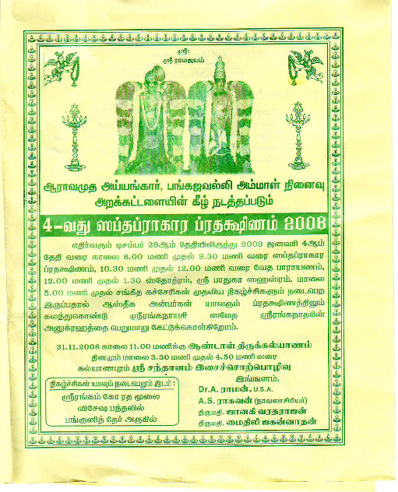

Page 2:

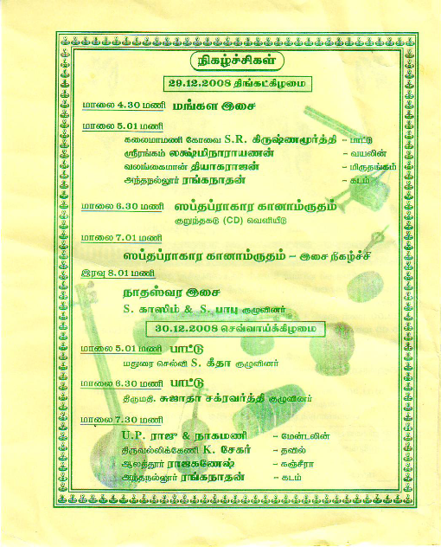

Page 3:

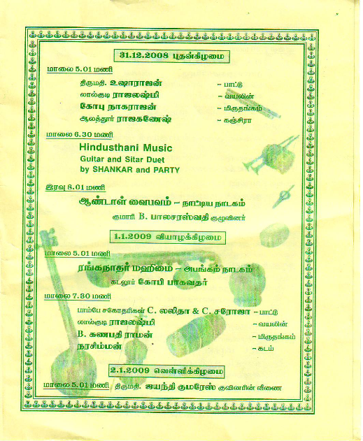

Page 4:

