NatyaRanga

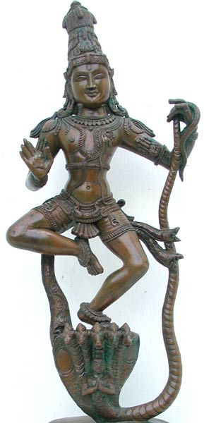

Invites you to join the celebration of

Sri Krishna Jayanti

with a

GRAND DANCE GALA
(Performances by various schools)

on
Saturday, September 16, 2006
1:00 pm – Shayanotsavam

at

RangaMantapam

Shree Ranganatha Temple
8 Laden Town Road, Pomona, NY – 10970
Telephone: 845-364-9790

Please feel free to bring your friends and relatives to the program.

Contact:

vijaya@sundararanga.com, ramsey1228@yahoo.com, ramaswamychitra@yahoo.com, sudharsanas@yahoo.com, dyeluri@yahoo.com

There is no entrance fee. Donations are welcome. All donations will go to Sri Ranganatha Temple.

Please visit www.ranganatha.org for directions and any poojas that you want to sponsor.

Order of Events on the next page. . . . . . .
Sept. 16, 2006
ORDER OF EVENTS
******************************************************************************

Gopiyar Lolan …Dashaavataaran
Members of Ragahastha Performing Arts
Guru: Sudharsana Srinivasan

ShringaaraKrishna
Members of Sanskriti school of dance
Chitra Ramaswamy

Jaya ! Jaya ! Deva Hare !
Members of Kalanjali
Guru: Sudha Devulapalli

He Deva!
Members of Ambika Raman Dance Academy
Guru: Ambika Raman

Madhuban Mein Raadhika
Chandralekha Kovvali
Member of Bharata Kamalalaya Institute of Bharata Natyam
Guru: Kamala Narayan

INTERMISSION

Vande Vaasudevam
Sahana Natesan
Member of Center for Kuchipudi Dance
Guru: Indira Sreeram Dixith

Krishna through the eyes of PurandaraDaasa
Members of Natya Anubhava
Guru: Nalini Rau

Krishnaaya Tasmai Namah
Members of Subhanjali
Guru: Subha Parmar

Sri Krishna Maahaatmyam
Members of Muktambar Fine Arts, Inc.
Guru: Saavitri Ramanand

Sri Krishna Paarijatham (abridged)
Members of Nritya Madhavi
Guru: Divya Yeluri

Mangalam

SHAYANOTSAVAM (at the sannidhi)

******************************************************************************

