History of the Temple

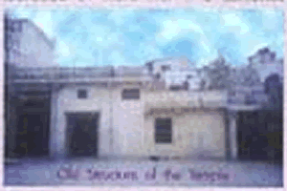
Narsimhaavataram stand out in a singular manner for God's action of protecting the good (Prahalada) and annihilating the evil (Hiranyakasipu). Sri Lakshmi Narasimha Swamy eugolised by the azhwars and Acharyas has shrines all over the country. To our fortune the Lord has a temple in Nala Bazaar, Secunderabad for more than two centuries, blessing the people all over.
This has an antiquity and the temple's Deity has been partonised by prominent persons of the twin cities. Over the past two centuries this temple's presiding Deity Sri Lakshmi Narasimha Swamy is a giver of boons (Varaprasadhi). Apart from the utsavamurthis of Sri Prahaladavaradan and his Concerts Sridevi and Bhoodevi. There is separate Sri Sannithi for Andal, Azhwars, Ramanujar and Vedantha Desikar, this being the only temple having Sri Sannithi for Sri Vedantha Desikar in the twin Cities. As per the original plan envisaged several decades ago the liking Kingsway (R.P.Road) to Musheerabad by negotiating through ths Temple was abandoned owing to several protests demonstrated by the devotees from all walks of life saving the temple from demolition and instead the road was linked through Tank Bund. The temple has a glorious record of regular daily and monthly poojas and annual uthsavams being celebrated on a grand scale with large public participation. In the past various Jeers, Peethadhipathis and Acharyas have done Mangalasasanam to the temple Deity. Now the temple is in a diplated state due to various factors.
It may be of Interest to note that, the then Nizam of Hyderabad worshipped the Lord of this temple. Even today some muslim devotees offer coconuts, betel leaves and nuts, flowers, incense sticks and fruits to the presiding deity. Procession of the Deity during the Brahmothsavam used to go through R.P. Road, Mahaboob College, Market Street and Subash Road bestowing his blessings to all residents and shopkeepers of the area as well as the people of twin cities. The daily, weekly, monthly and annual festivals of the Presiding Deity and Thirunakshathram of Azhwars, Ramanujar, Swamy Desikan and Acharyas used to be celebrated in grand manner with Large and generous contribution from the public of all walks fo life.
APPEAL
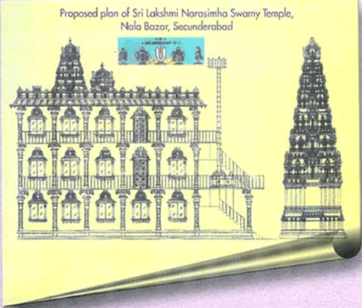
At the request of Sri Lakshmi Nrisimha Swamy Seva Samithi, the Endowment Department of Andhra Pradesh was kind enough to appoint Sri N.T Seshadri,
Secretary of the Seva Samithi as a single person Trustee of the temple. It is therefore proposed to undertake renovation/reconstruction of the temple to reestablish the glorious tradition with Blessings of the Lord and the guidance of the various Jeers, Peethadhipathis and Acharyas and Cooperation of the public for successful completion. Any venture of such magnitude requires physical, moral and financial support of devotees. Favourable responses from the devotees will be more than performing a Maha Yagnam and the devotees will receive blessings of Sri Lakshmi Nrisimha Swamy.
The estimated cost of this Divya Karyam of renovation of the temple will be about One Crore Rupees. Sri Lakshmi Nrisimha Swamy Seva Samithi earnestly appeals to all the devotees to contribute their mite for successful completion of first and foremost task of the Samithi so that it will encourage the Samithi to take up more such tasks with greater enthusiasm. Also Proposed to construct are the temples of sri sannidhis of sri Padmavathi sametha sri Venkateshwara Swamy and Sri Sudharshanan & Yoganarasimhan
It is estimated that the cost of renovation and reconstruction of the temple by using quality and best materials till the final finishing are approximately worked out as follows. The major cost involve for the following:
• 60 Pillars with cross beams and surrounding roof @ Rs.50,000 per pillar | Rs.30,00,000
• Presiding Deity Sri Lakshmi Nrisimha Swamy Sannidhi, Garbalayam, Vimanam, Gopuram and additional idols | Rs. 7,50,000
Other Sannidhis, /Garbalayam and Vimanam, Gopuram and Idols
• Sri Venkatesa Perumal Sannidhi | Rs. 3,50,000
• Sri Sudarshana Alwar and Yoga Narasimhar Sannidhi | Rs. 3,50,000
• Sri Andal, Alwars, Acharyas – Ramanujar Swamy Desikar Sannidhi | Rs. 3,50,000

• Dwajasthambam – foundation to roof level Including Balipetam, Garudalvar, Anjaneyar Sannidhi | Rs.12,00,000
• Rajagopuram – Foundation to third floor, in All 4 stages @ 2,50,000 per stage | Rs.10,00,000
• Vishwaksenar Sannidhi and Thirumadapalli @ Rs.2.0 lac each | Rs. 4,00,000
Besides above, separate rooms for visiting Jeers and Acharyas, Ardha Mandapam, Mukha Mandapam, Mirror room, two special rooms with place for Veda Patasala in the first floor and Vahana Mandapam in ground floor form part of the whole work.
Your generous contributions will go long way to complete the noble deed in a record time. For donations Rs.50, 000 and above, donors’ names will be displayed at the appropriate place in the temple. Please send your contributions for the
Maha Karyam by way of cheque / draft favouring: Sri Lakshmi Nrisimha Seva Samithi may be sent to
Sri Lakshmi Nrisimha Swamy Seva Samithi
Regd. No. 251/03
3-4-747, Narayanaguda, Hyderabad - 500 027
Note: NRI are requested to become members by paying a Membership Fee 0f $100 (USD) and perform ANNUAL PUJA on their chosen day paying $ 50 (USD)

